Rest of the content is already explained in the Readme.md file. Here, we are doing the Github Action setup as we are providing the docker username and password that is required in yml ile:

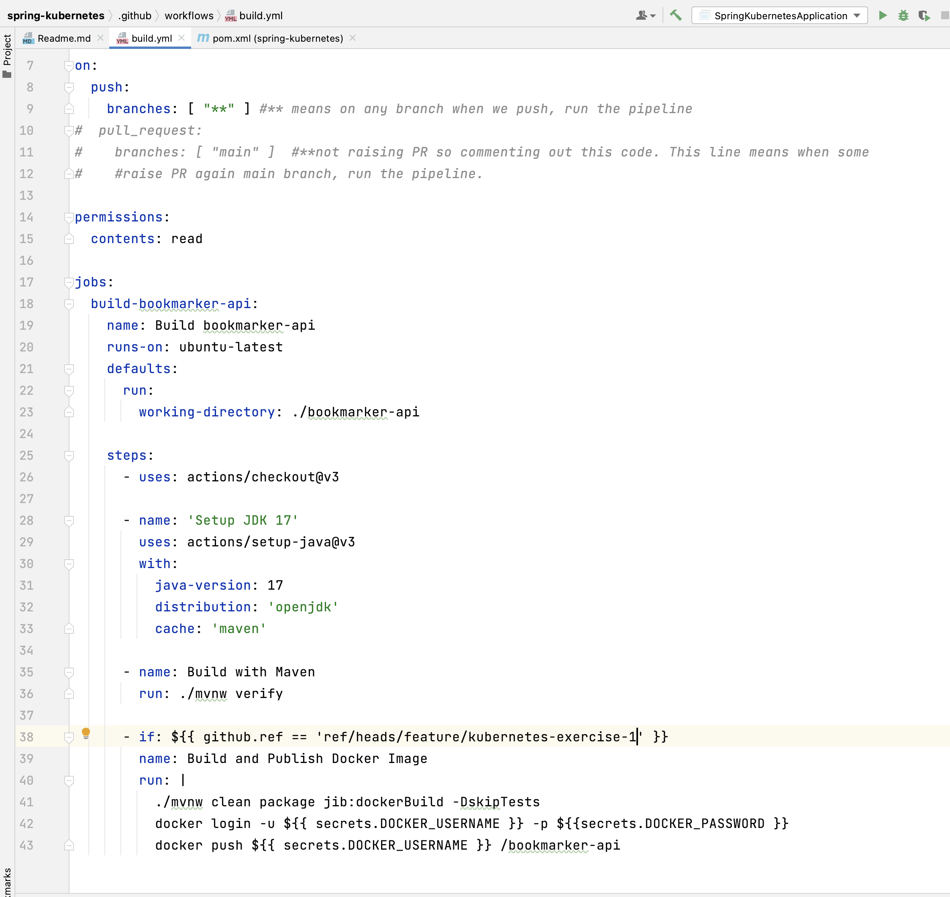

line no, 42, we need docker username and password. That setup we will configure here.

Steps:

1. Go to your repo and go under security.

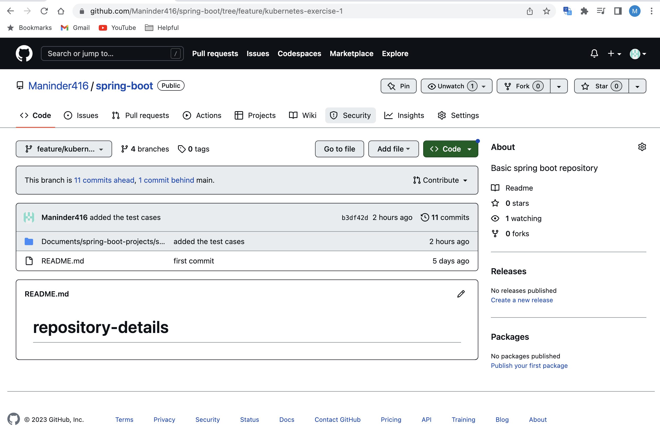

1. Under security tab, click on action under “secrets and variables.”

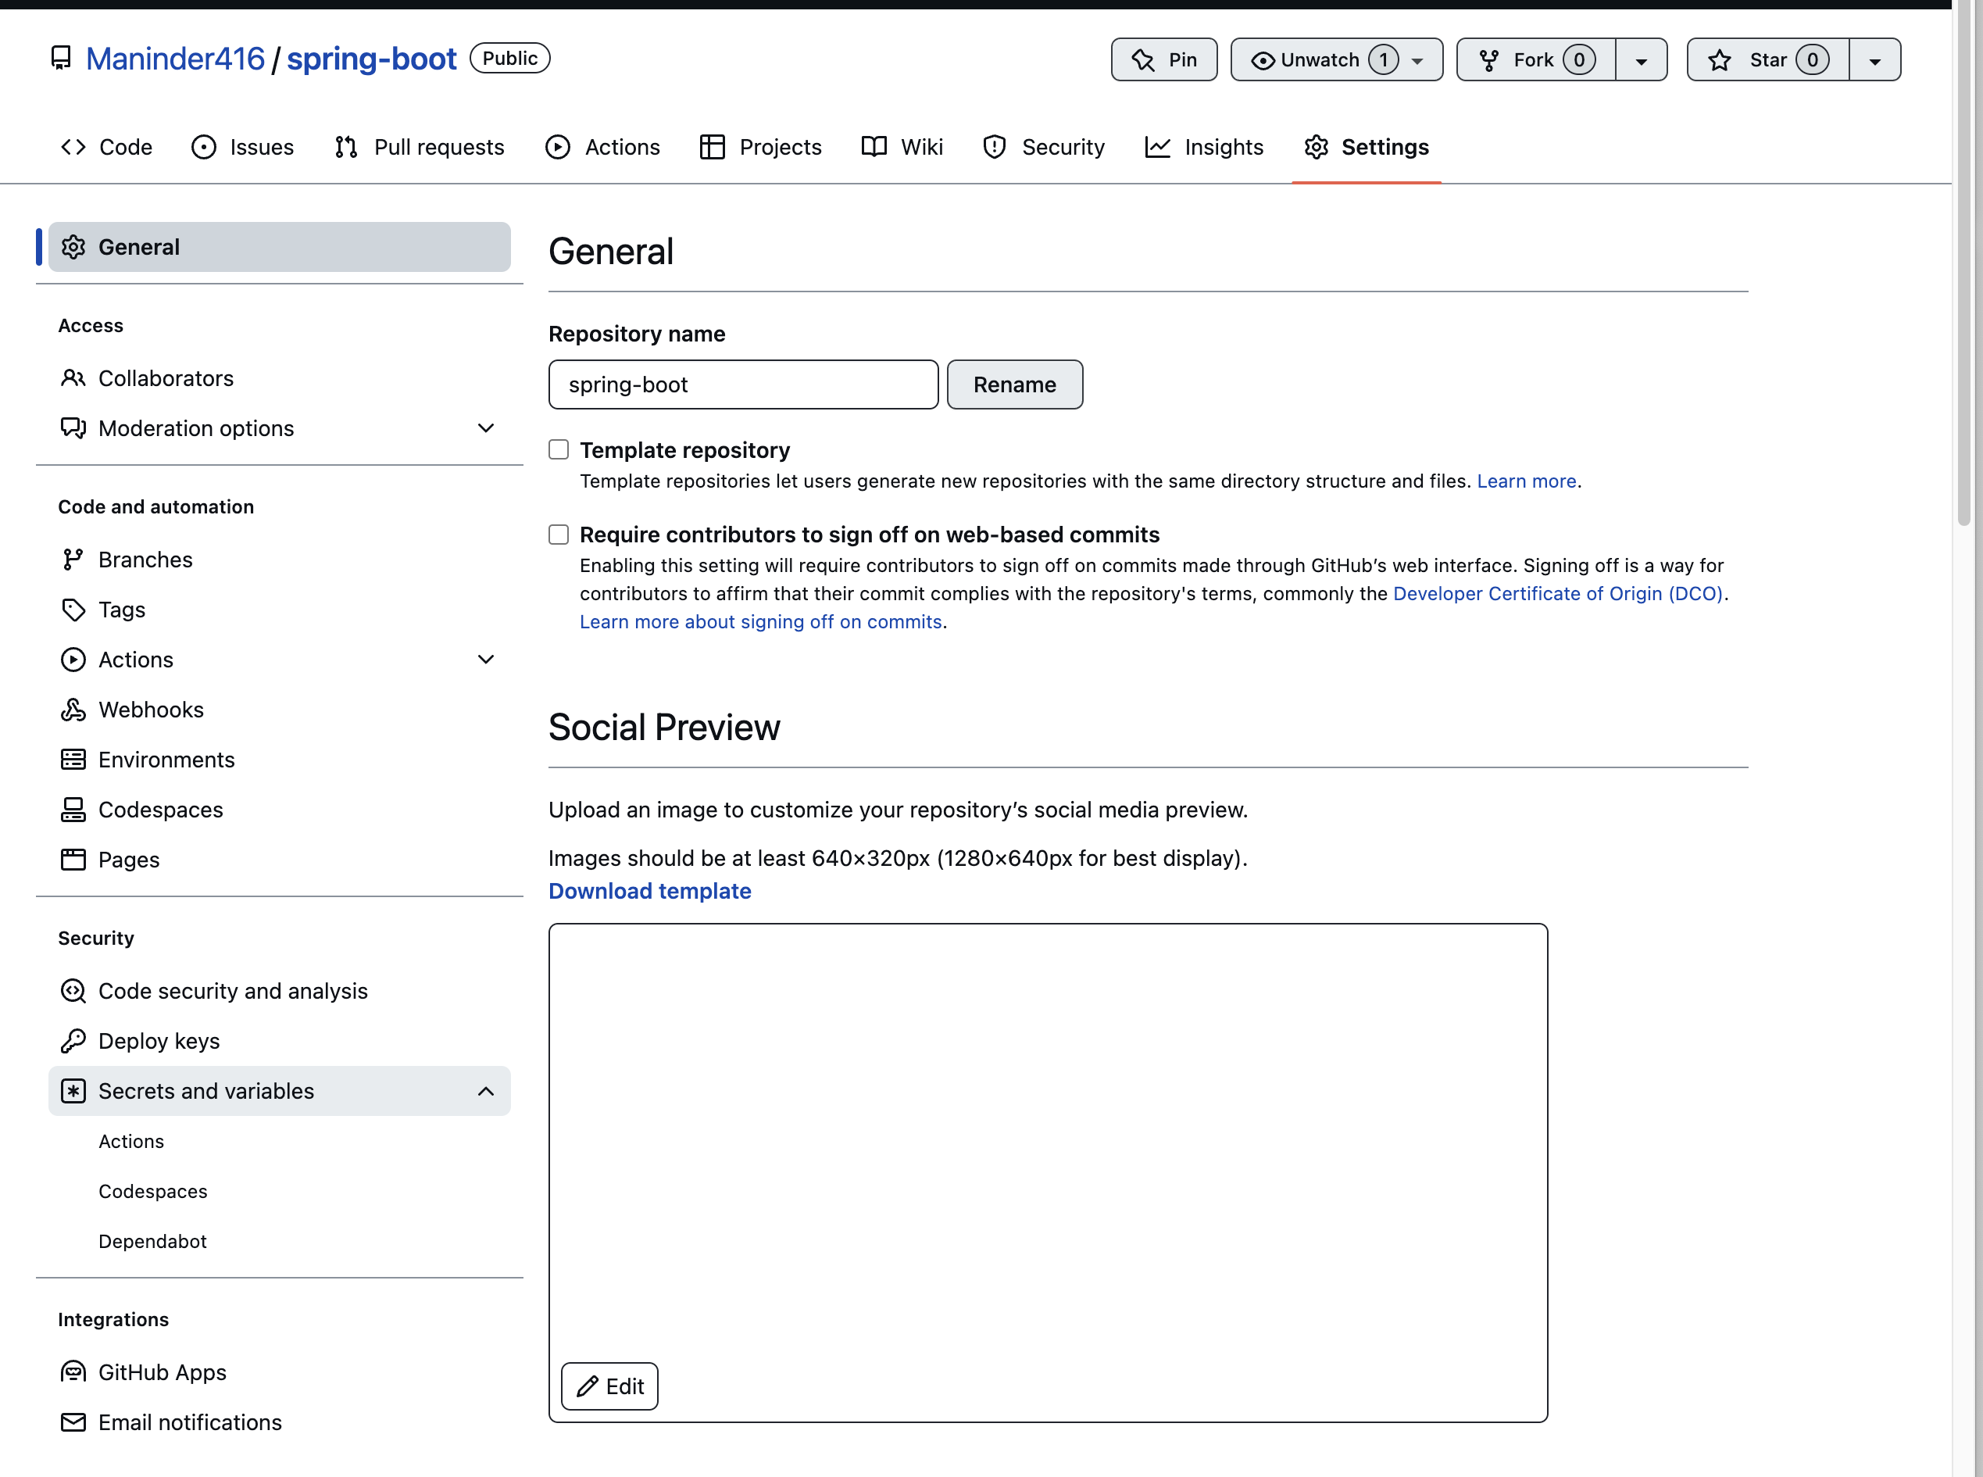

1. Click on “new repository secret.”

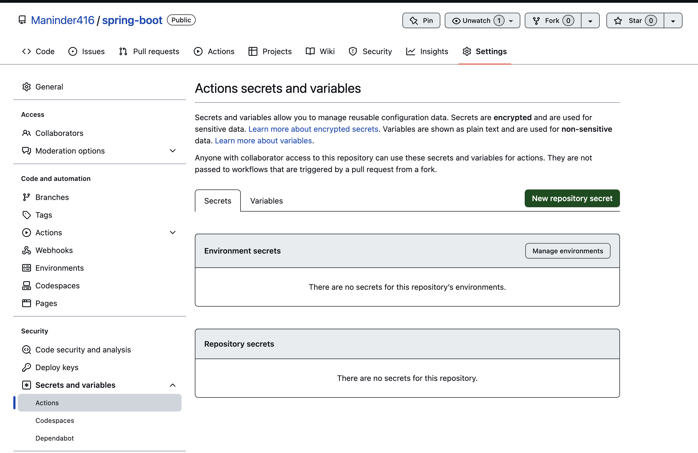

1. Provide the same variable name defined in yml file:

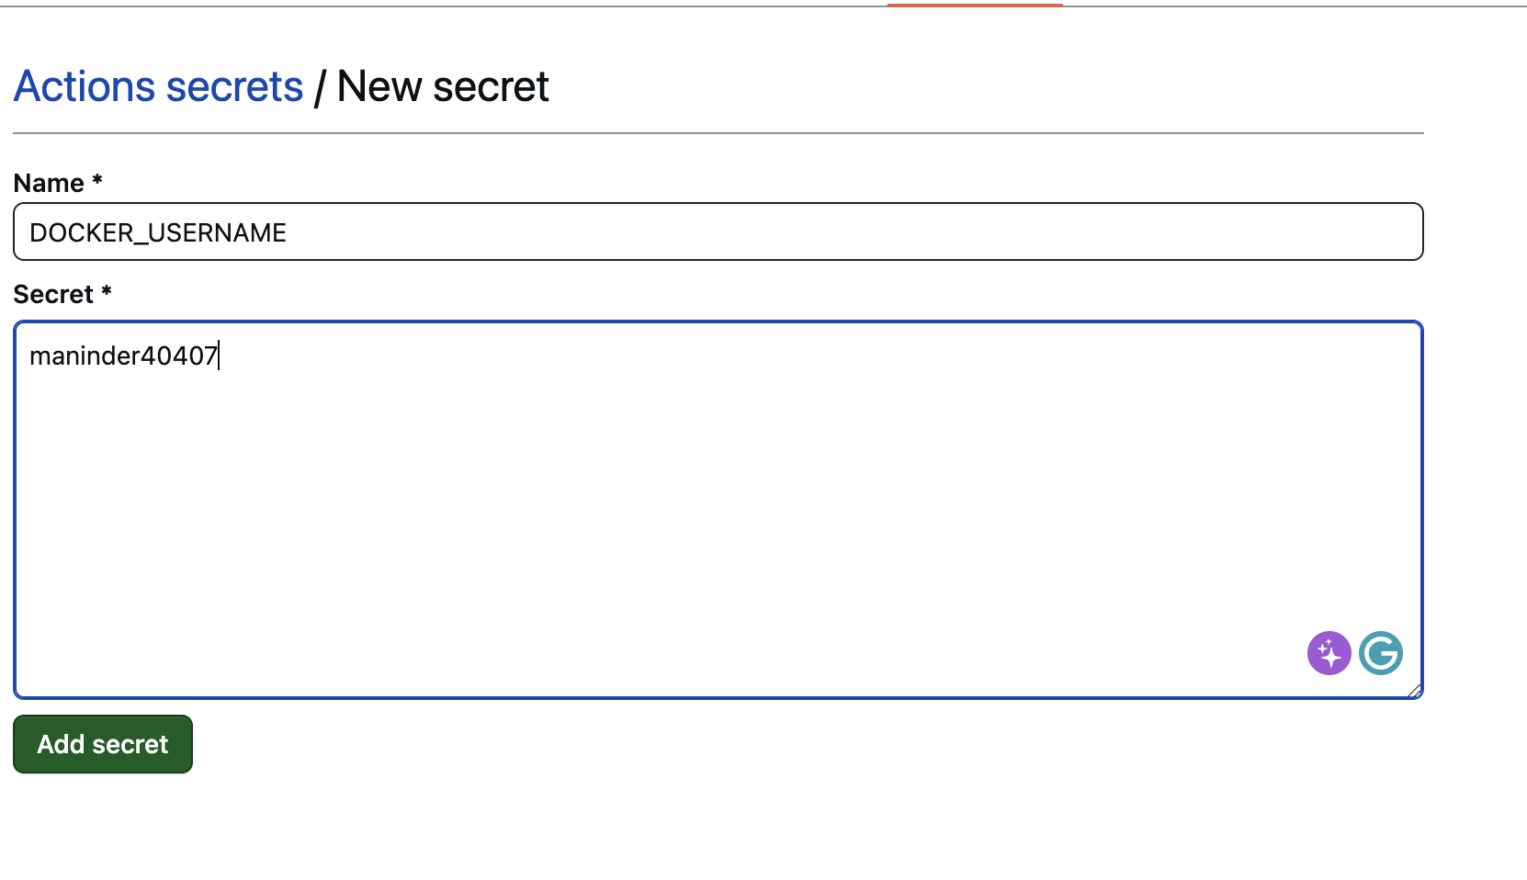

1. Add both username and password for docker hub:

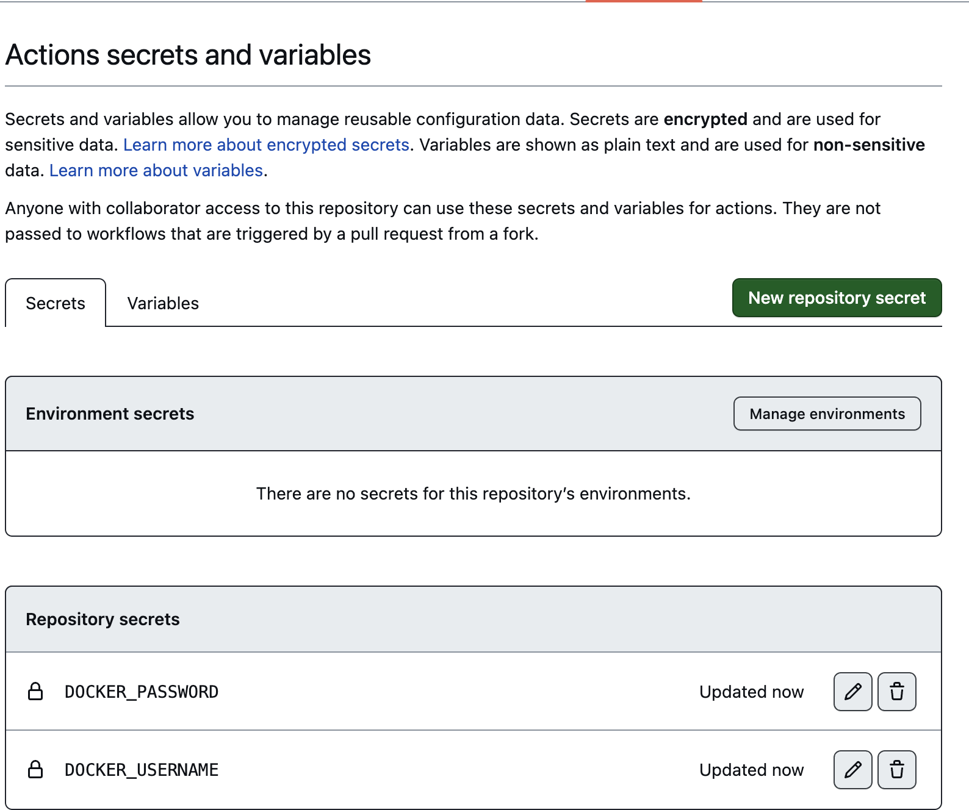

Once this is done, we need to create **“.github/workflows/maven.yml**” file.

**Working maven.yml file:**

name: project cicd flow

on:

push:

branches: [ feature/kubernetes-exercise-1 ]

pull_request:

branches: [ feature/kubernetes-exercise-1 ]

jobs:

build:

runs-on: ubuntu-latest

steps:

- uses: actions/checkout@v2

- name: Set up JDK 17

uses: actions/setup-java@v1

with:

java-version: '17'

distribution: 'adopt'

cache: maven

- name: Build with Maven

run: mvn clean install

- name: Test cases execution

run: mvn clean test

#if condition, if the branch is equal to main then create the docker image for it and push to docker hub

#bookmarker-api-jib:latest image name defined in docker push command below will pick from image

# name defined in pom. file in JIB plugin. If you want to user dockerFile then you should define

# file path but here we are using JIB so it's picking from pom.

- if: ${{ github.ref == 'refs/heads/feature/kubernetes-exercise-1' }}

name: Build and Publish Docker Image

run: |

echo "This job runs in custom branch"

./mvnw clean package jib:dockerBuild -DskipTests

docker login -u ${{ secrets.DOCKER_USERNAME }} -p ${{ secrets.DOCKER_PASSWORD }}

docker push ${{ secrets.DOCKER_USERNAME }}/bookmarker-api-jib:latest

Make sure spring boot project folders like this:

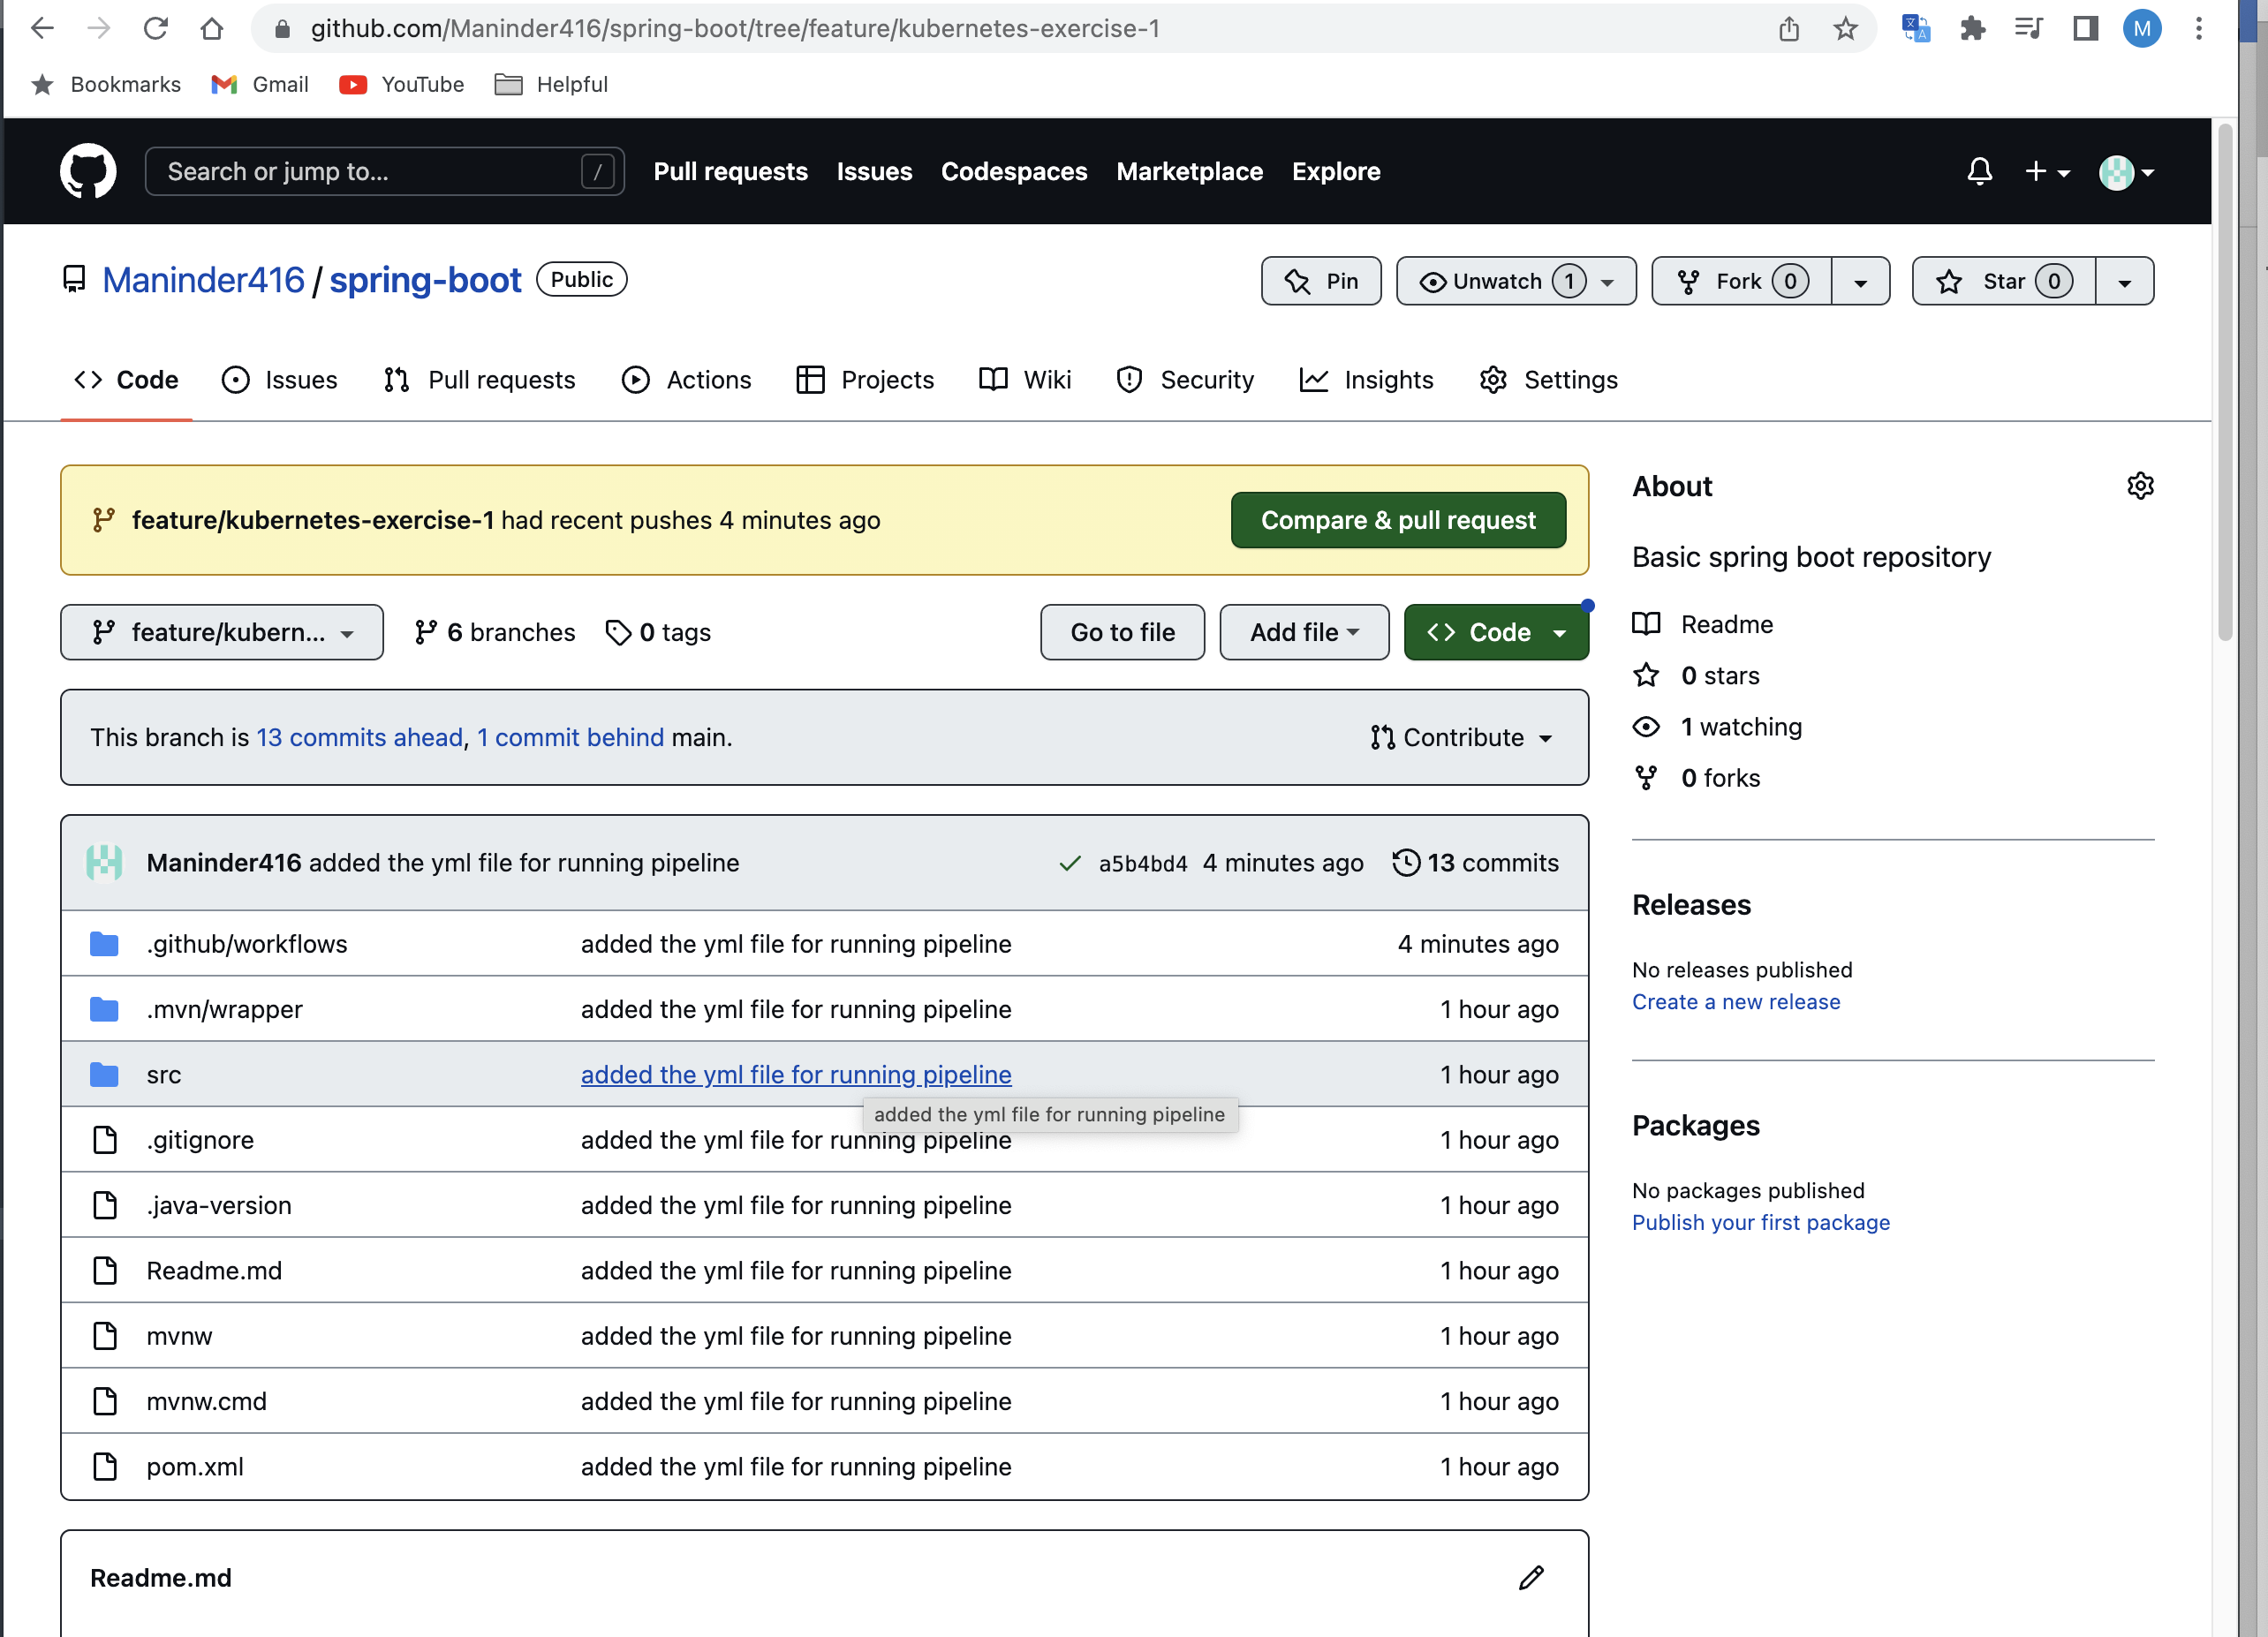

Earlier, I had folder like “Documents/spring-boot-projects/branch name” and due to that my Github action was not working.

The image name we defined online

no 37, picked from pom.xml file jib plugin:

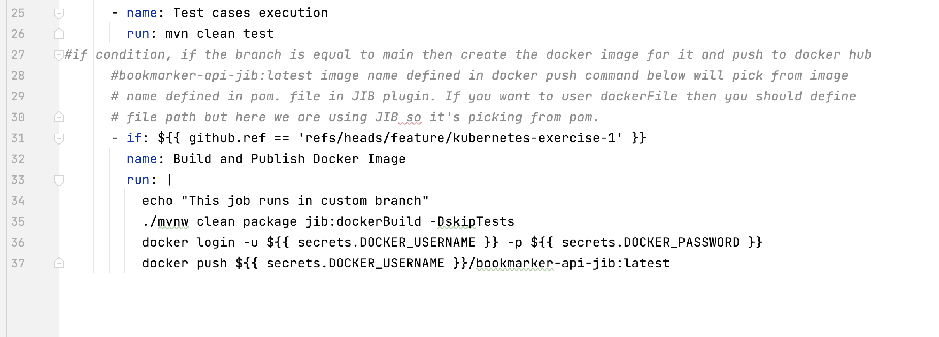

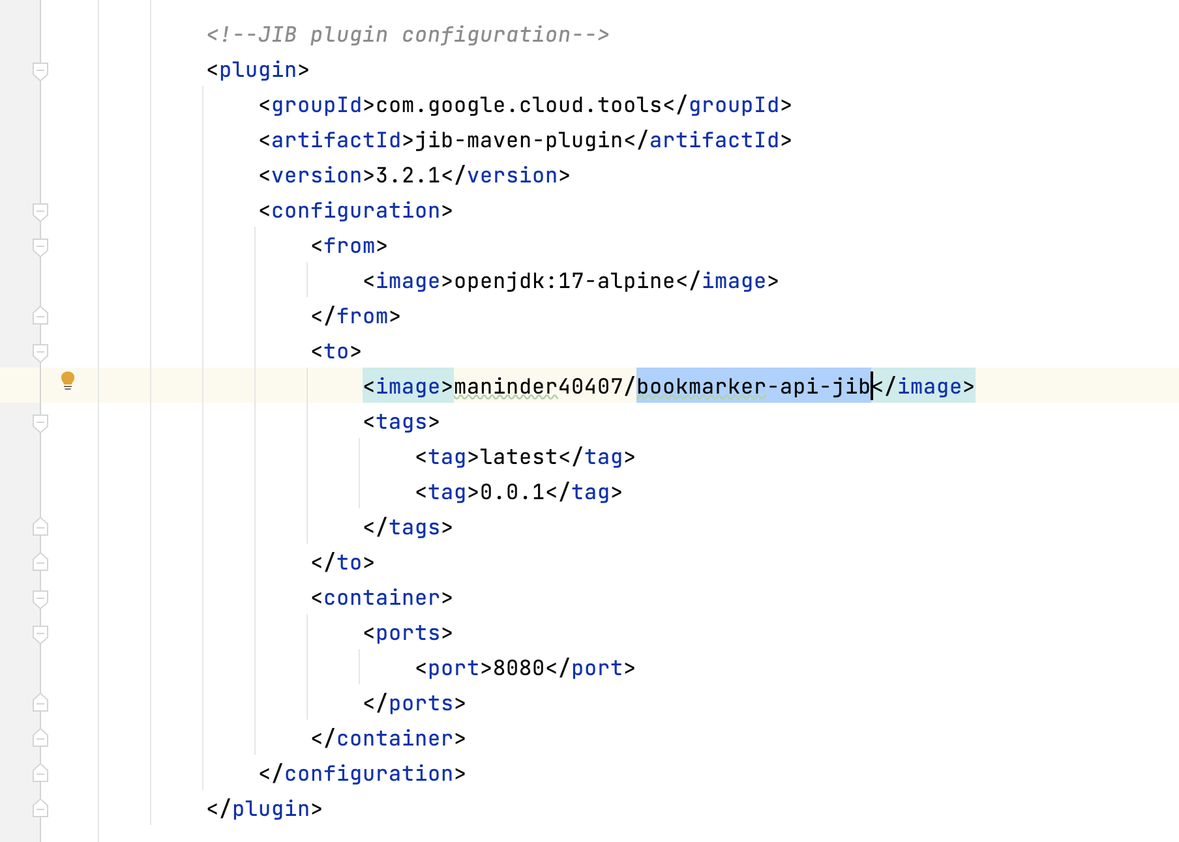

Once that is done, you are good to go….

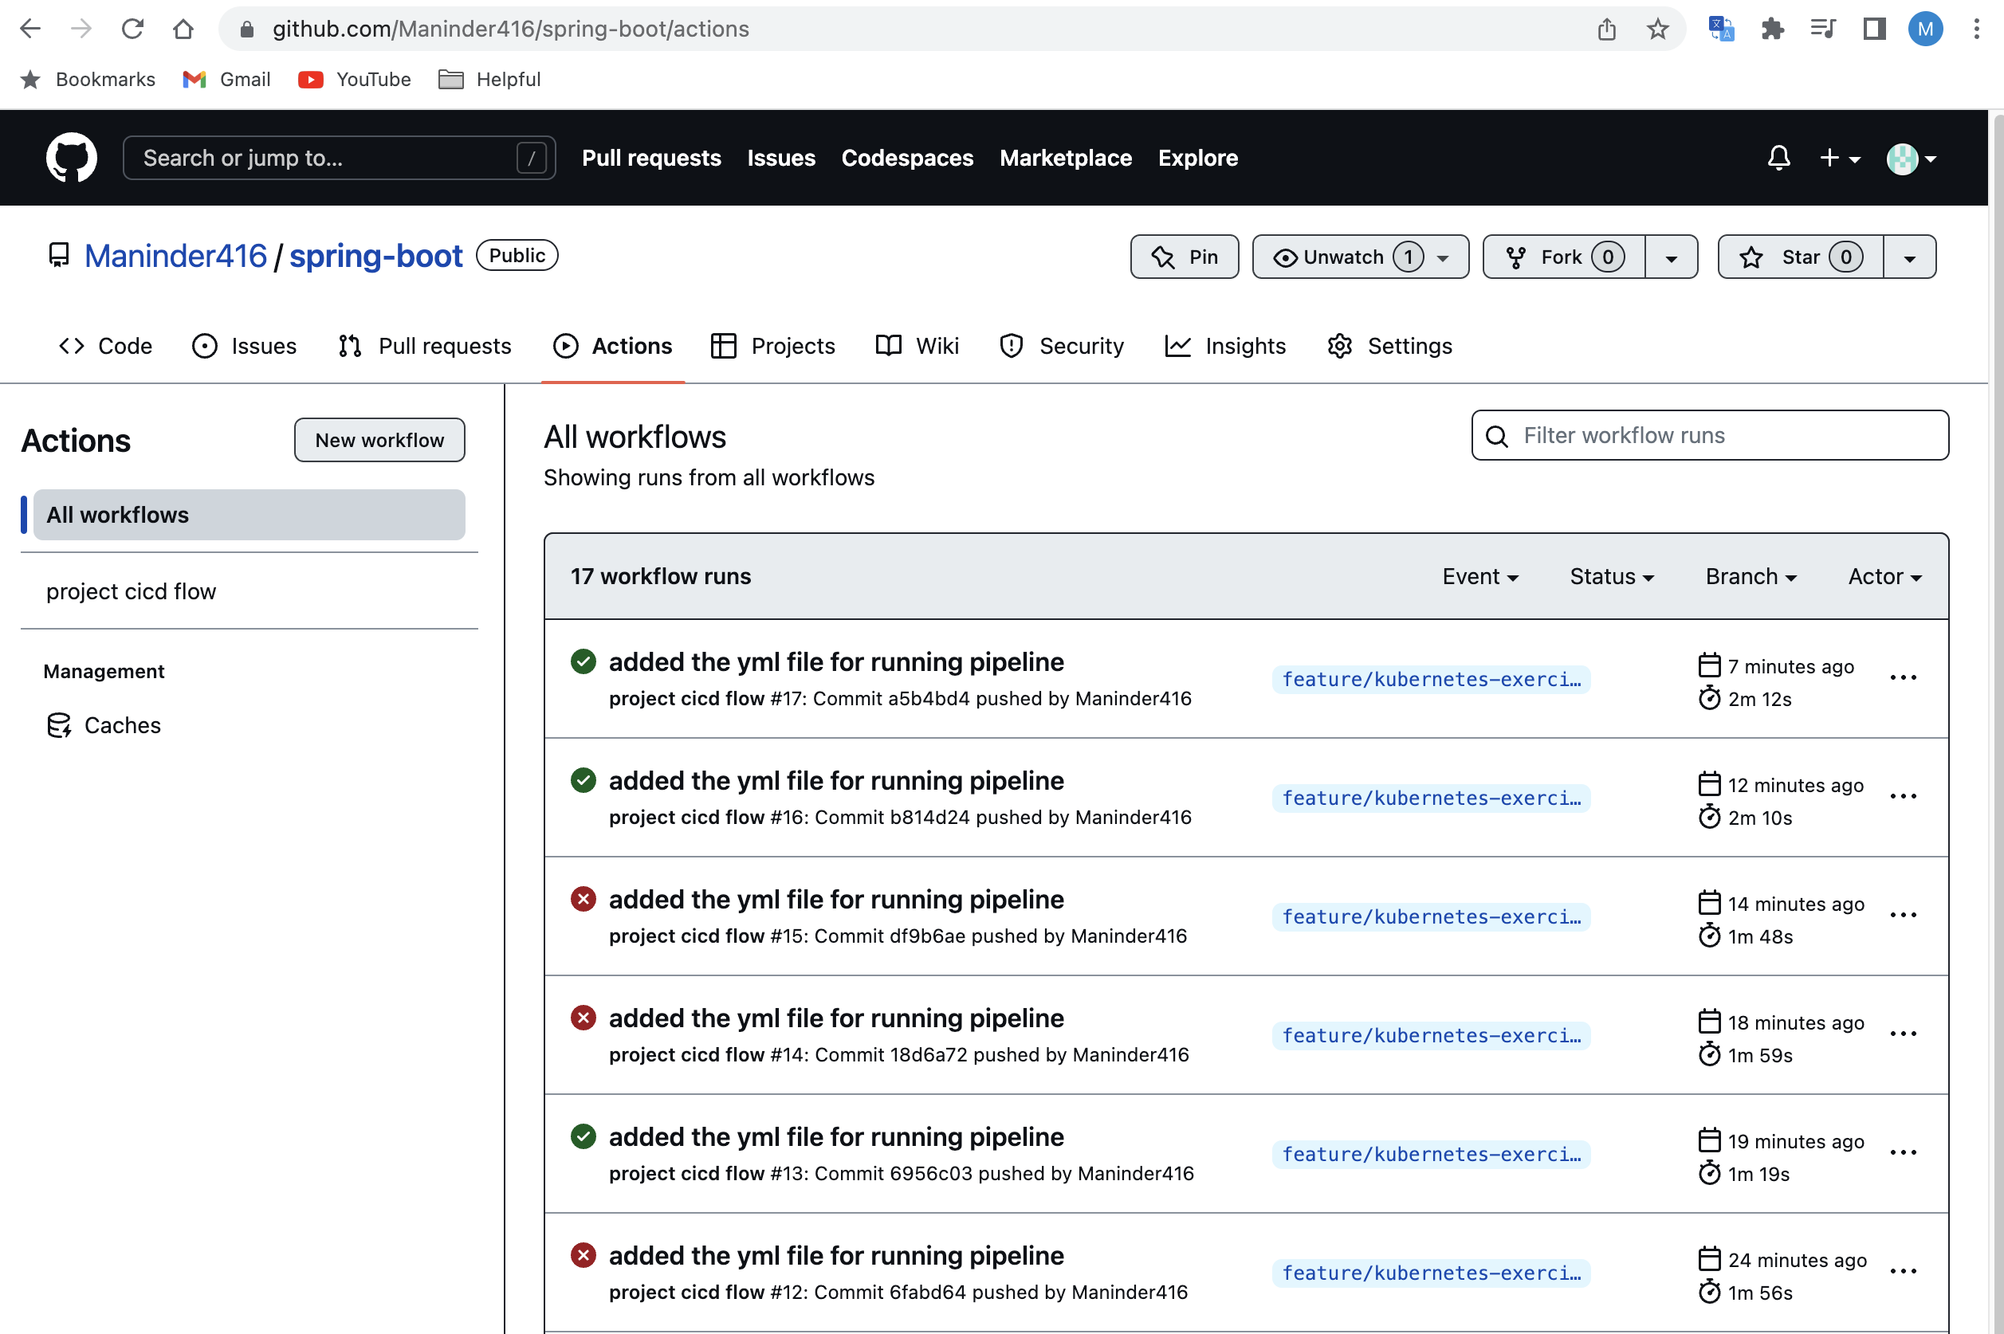

16. Now, we will add post method for bookmark. For bookmark method, we are not giving all details. We are passing only 2 arguments so that's why I have created the "BookmarkRequest" class for taking the input and add @Valid @NotEmpty annotation.

17. Now, if there is something error in your payload then it will through big error, that’s good

but we need an accurate error due to which our post method is failed. So, we need to add one annotation.

**to fix it:**

<problem-spring-web.version>0.27.0</problem-spring-web.version>

**<dependency>**

**<groupId>org.zalando</groupId>**

**<artifactId>problem-spring-web-starter</artifactId>**

**<version>${problem-spring-web.version}</version>**

**</dependency>**

Before applying this annotation, the error will be like this:

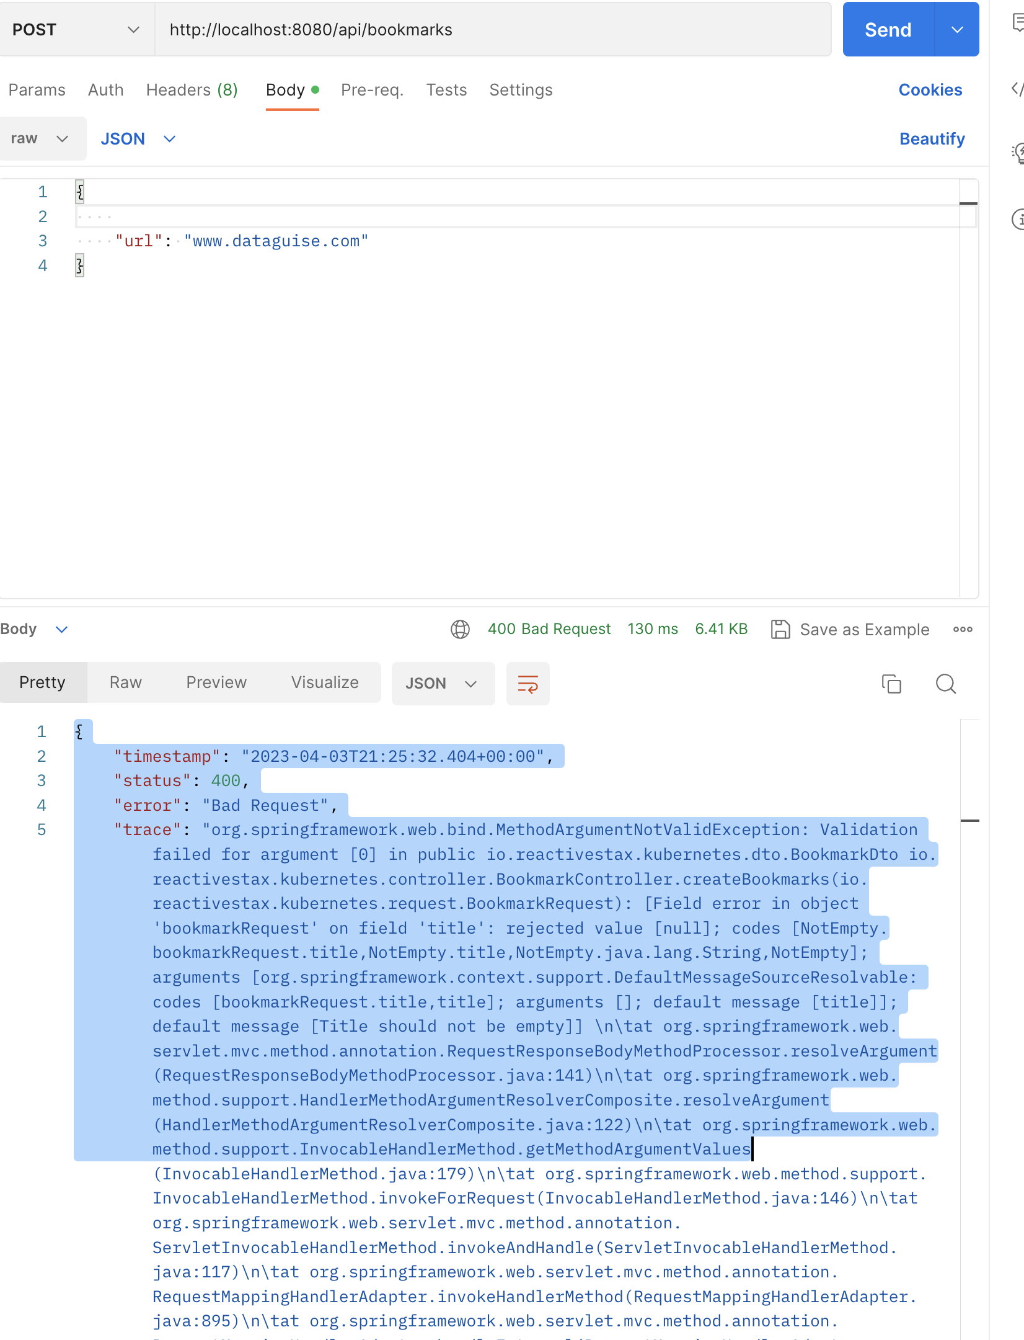

**After adding this dependency:**

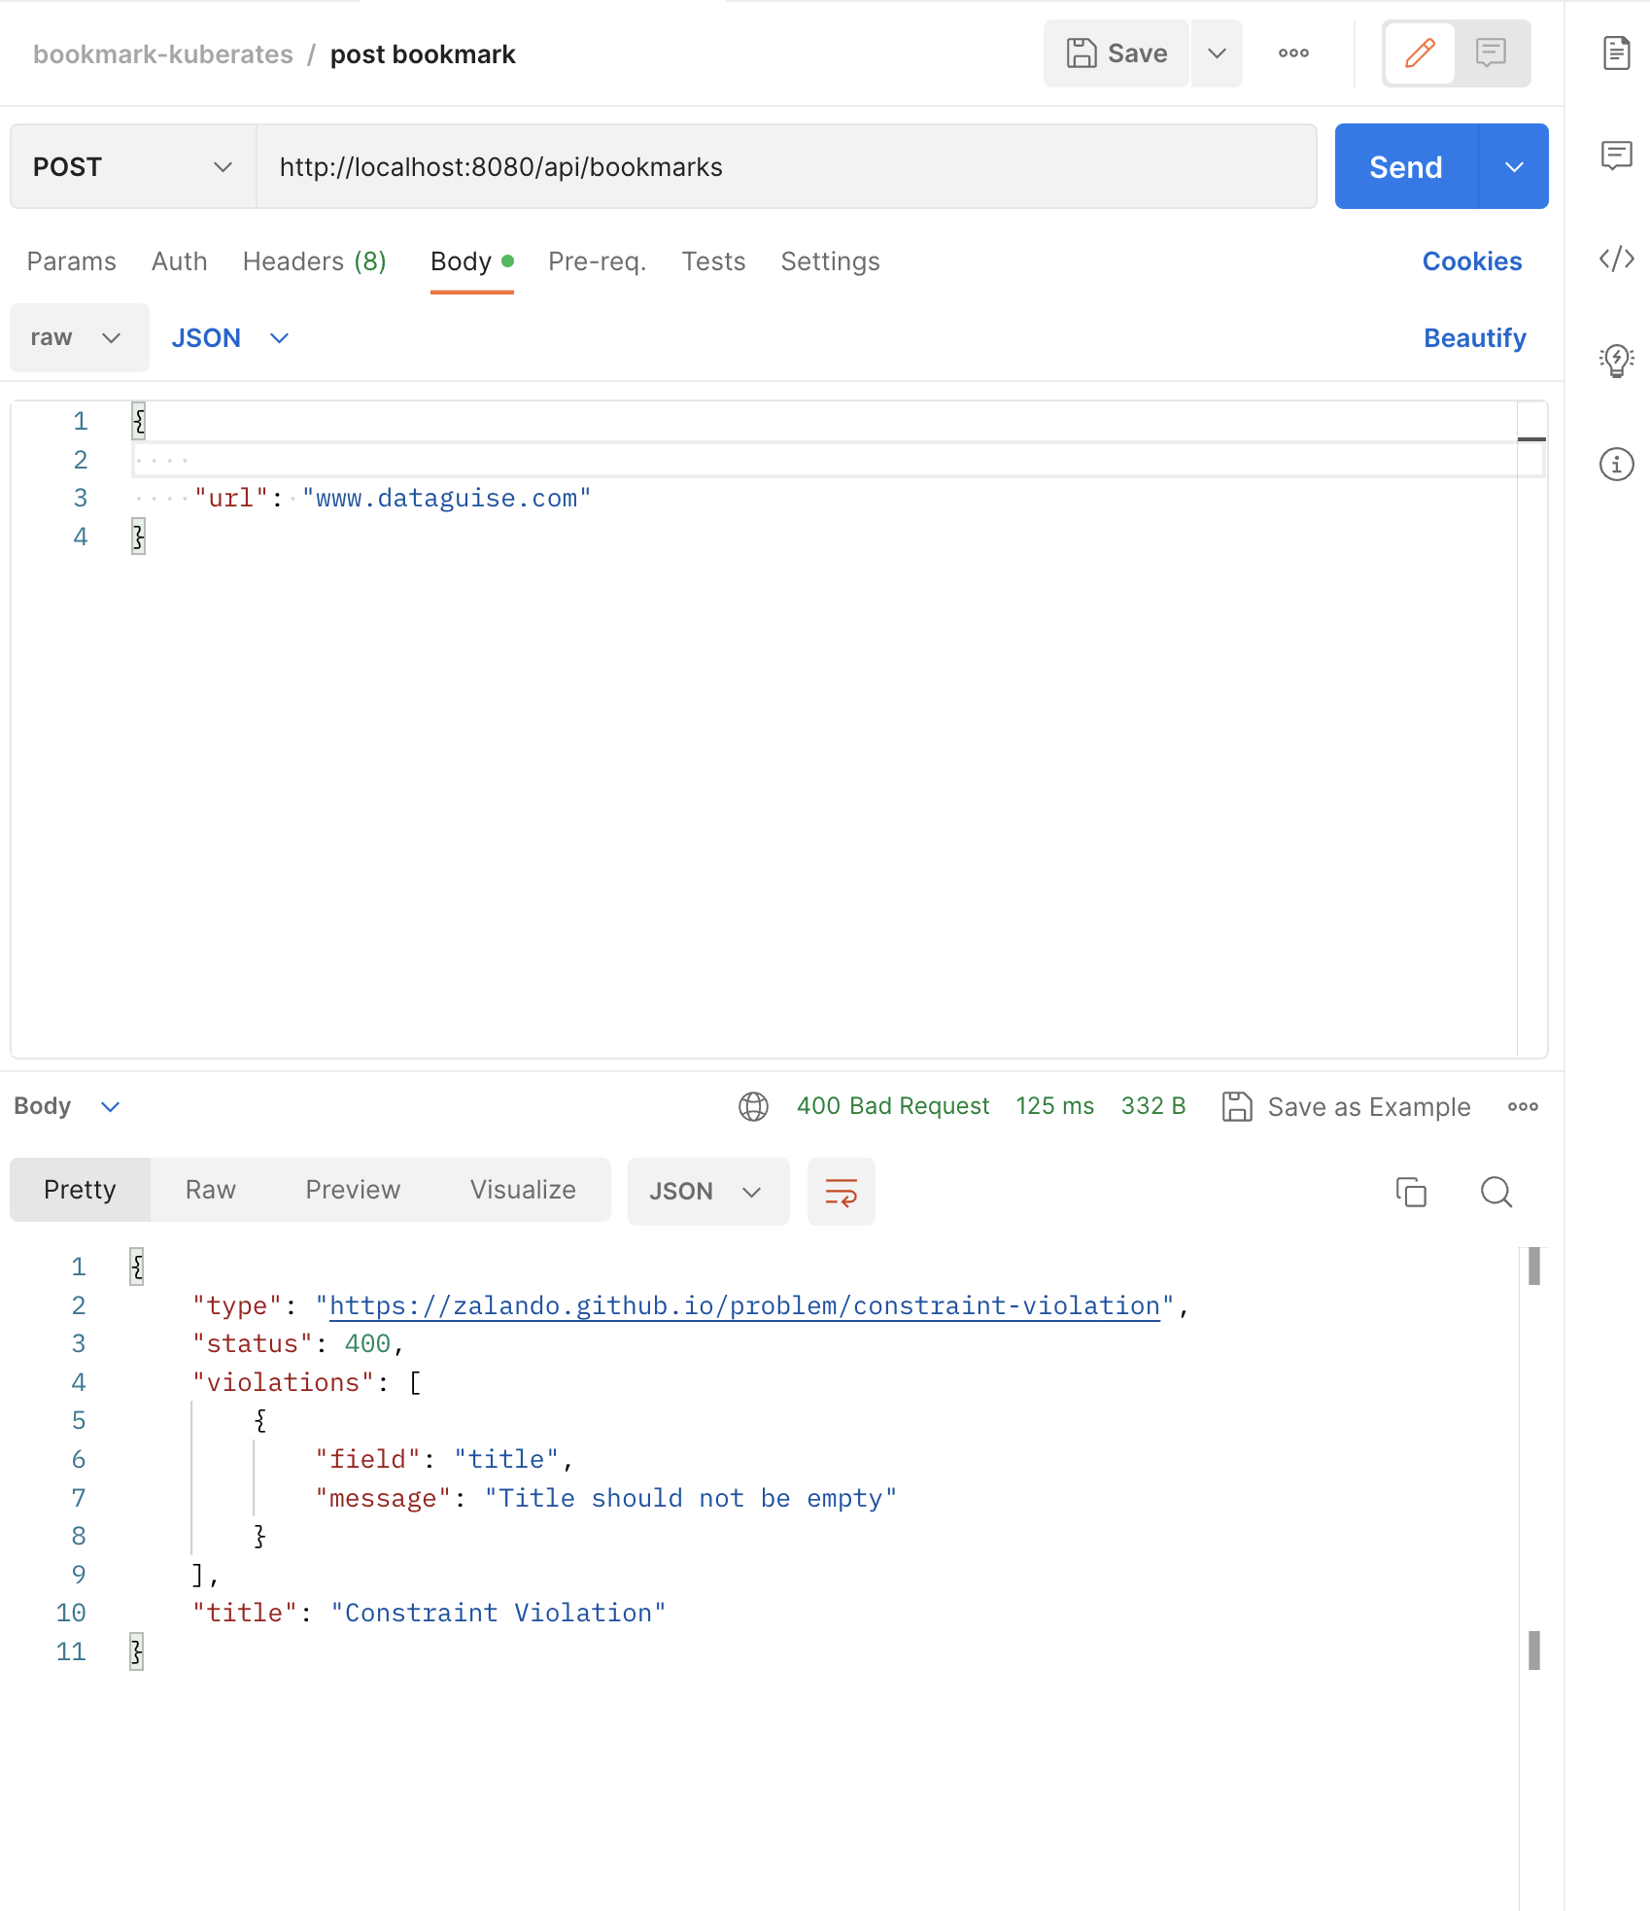

**Docker-Compose.yml:**

Until now, we create the common docker-compose file for all the services like for spring boot app along with databases that we are using. If you want to change anything in your spring boot application, then you down all the services that are running in docker-compose however we just need only application to restart. So, this is not a right approach. Instead of it, we can create 2 docker-compose files in which under one file we mention information regarding the spring boot app and for other services we will create a different docker-compose file.

So, we created 2 files:

1. docker-compose.yml: it contains all the services like DB.
2. docker-compose-app.yml: It contains only spring boot app.

Now, spring boot app is dependent on the service that is present in another docker file. So, here is the way to run multiple docker files together:

**docker-compose -f docker-compose.yml -f docker-compose-app.yml up -d**

**logs:**

**docker-compose -f docker-compose.yml -f docker-compose-app.yml logs -f**

Still, these commands are not easy to remember so we can create a shell script to run these commands:

Now, will create a shell script named as “run.sh”

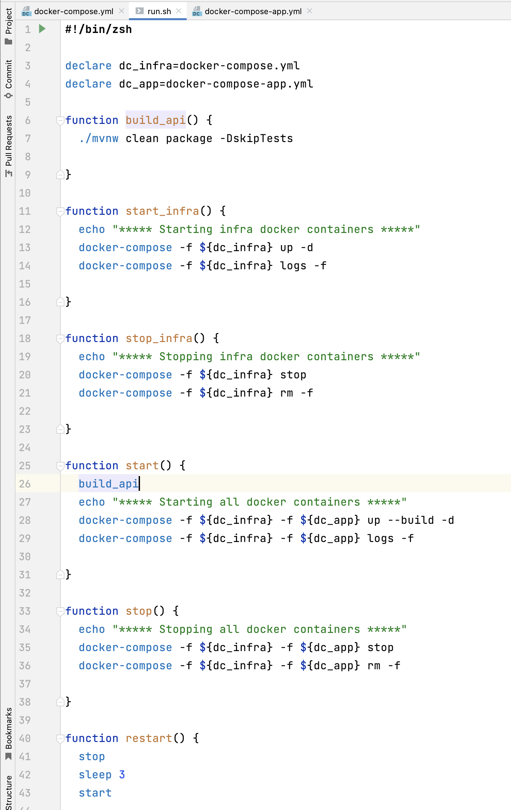

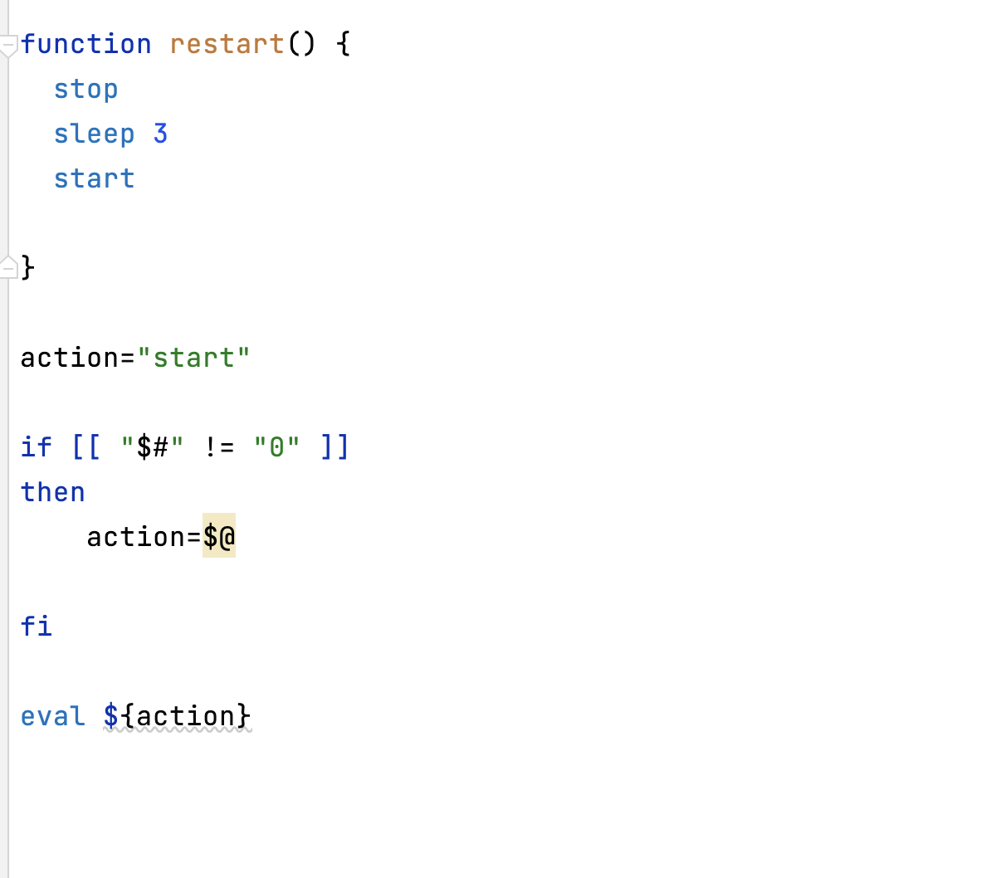

In this file, we will write the different methods to execute our spring boot app.

Steps:

1. create “run.sh” file
2. execute “chmod +x run.sh”
3. run “./run.sh” file

when you execute this file, it will by default call the “start” method written inside this file as we mentioned the default action to the “start” method.

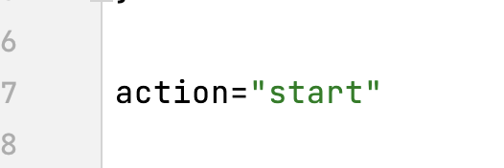

It will run both the docker-compose files and our app will up and work.

But if you want to restart the existing running application then you can do it by providing the method name as:

For stop the containers: **“./run.sh stop”**

For starting only infra: “**./run.sh start_infra”**

Meantime, when we run our application using “run.sh” file, it will run in docker. So, if we want to see tables are getting created or not or if you want to see other things you need to login into the docker container. It is time consuming so to avoid this, we can run spring boot app in local profile.

Steps:

1. Run the “**./run.sh start_infra”** // it will run the docker postgres.
2. Create the “application-local.properties” file.

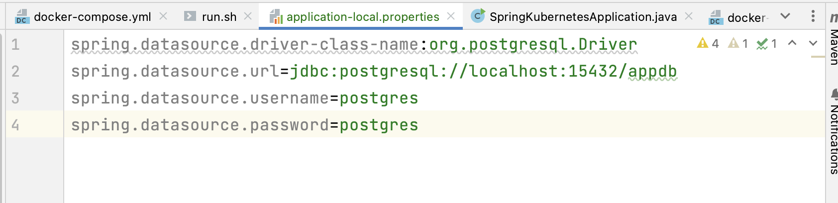

Added the host as localhost because docker postgres DB is running on local docker and assigned the local port to 15432 as we assigned it docker-compose file.

Run the spring boot in local profile: **-Dspring.profiles.active=local**

Now, it’s time to create frontend page for this spring boot app. So, for this we are using “next js”.

Steps:

1. Download <https://nodejs.org/en>
2. After installing node, run this command under our spring boot app folder:

“**npx create-next-app bookmarker-ui-nextjs --ts**”

**Create-next-app** is syntax to create next app.

**bookmarker-ui-nextjs** is our next app name.

**--ts** means we are using typescript over the JavaScript.

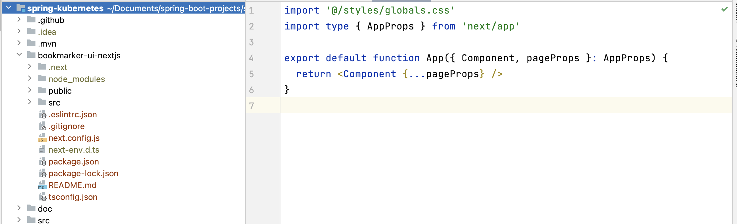

1. Now, go inside this folder “**nextjs-demo**” and run the “**npm run dev**”
2. Our application will start on localhost:3000 port.

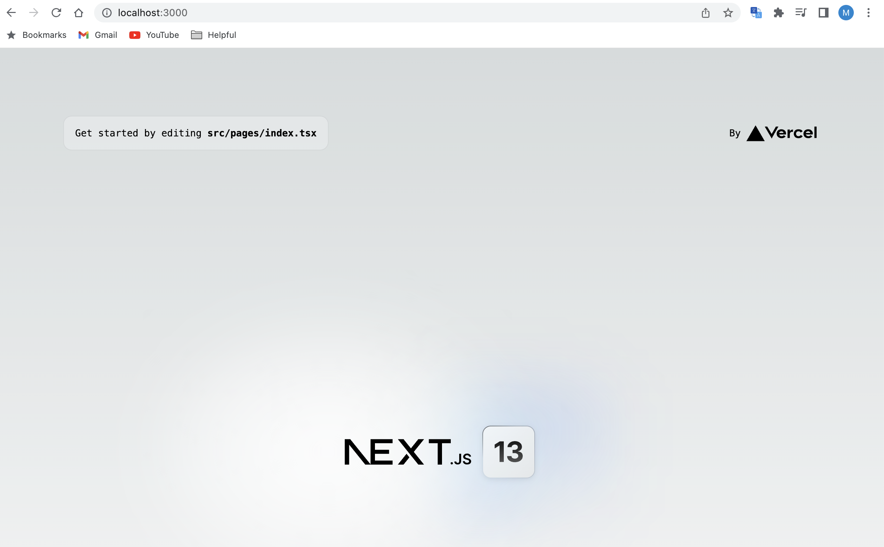

1. Inside the nextjs folder, also install the bootstrap server using command:

**npm i** [**bootstrap@5.3.0-alpha3**](mailto:bootstrap@5.3.0-alpha3)

1. Bootstrap server, we use for responsive websites. So, we have added it into nextjs project. To load this dependency, inside the project, import it inside the **“_app.tsx”**

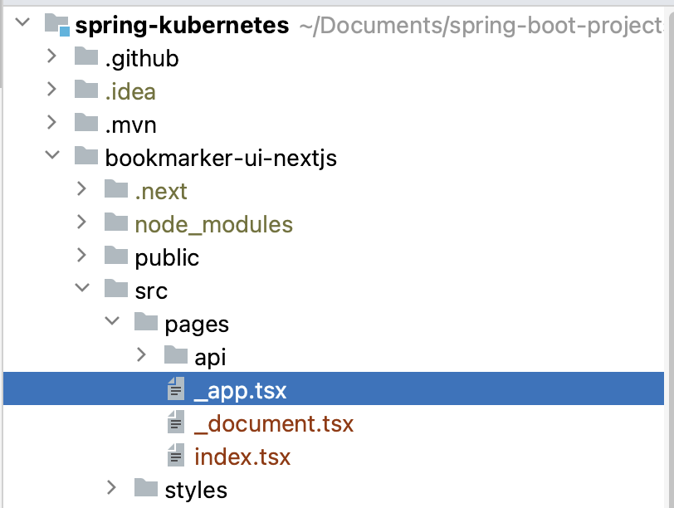

1. Import the bootstrap server in this file:

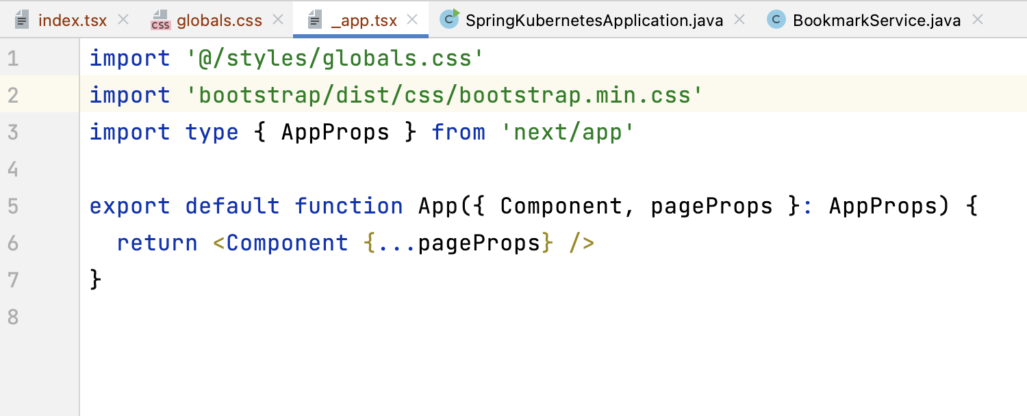

1. Once, bootstrap is imported. Now we can use it in global project:

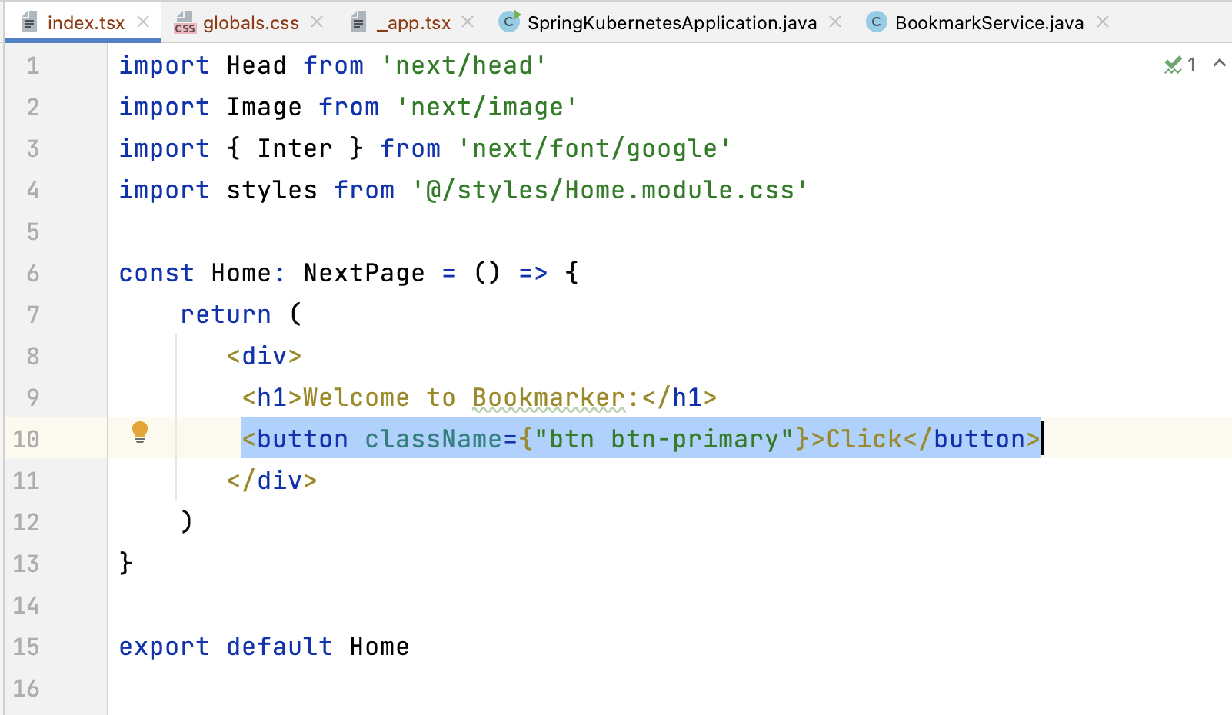

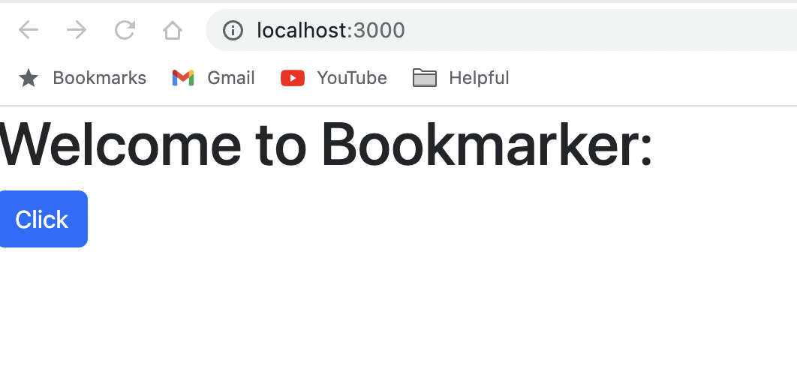

1. Check the button, bootstrap server is working as expected.
2. Meantime, not doing the UI work as we need to learn about next, react.

**Kubernetes:**

Docker and Kubernetes are two different technologies that server different purposes in modern software development.

Docker is a containerization platform that allows developers to package an application and its dependencies into a single unit called a container. This makes easy to deploy and run the application consistently across different environments.

Kubernetes, on the other hand, is an orchestration platform that helps manage and scale containerized applications. It automates the deployment, scaling and management of containerized applications and provides features such as load balancing, auto-scaling.

while docker provides a way to package and distribute applications, Kubernetes provides a way to manage and scale those applications in a distributed environment. Kubernetes also supports other container runtimes.

Kubernetes was initially designed by google and now it is maintained by CNCF (Cloud native computing foundation). It is written in Go Lang.

**Basic work of Kubernetes**:

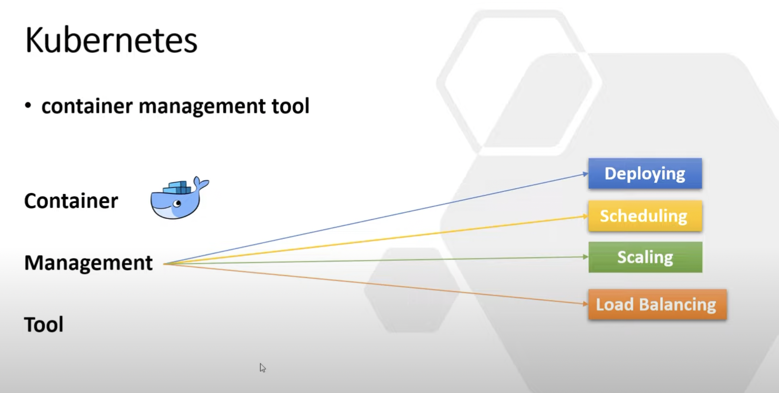

**Why Kubernetes comes into picture:**

Let’s take an example, we have 2 microservices and using one DB and these microservices are communicating with each other using Kafka. So, total we have 4 docker images:

1. Microservice1
2. Microservice2
3. Kafka
4. DB

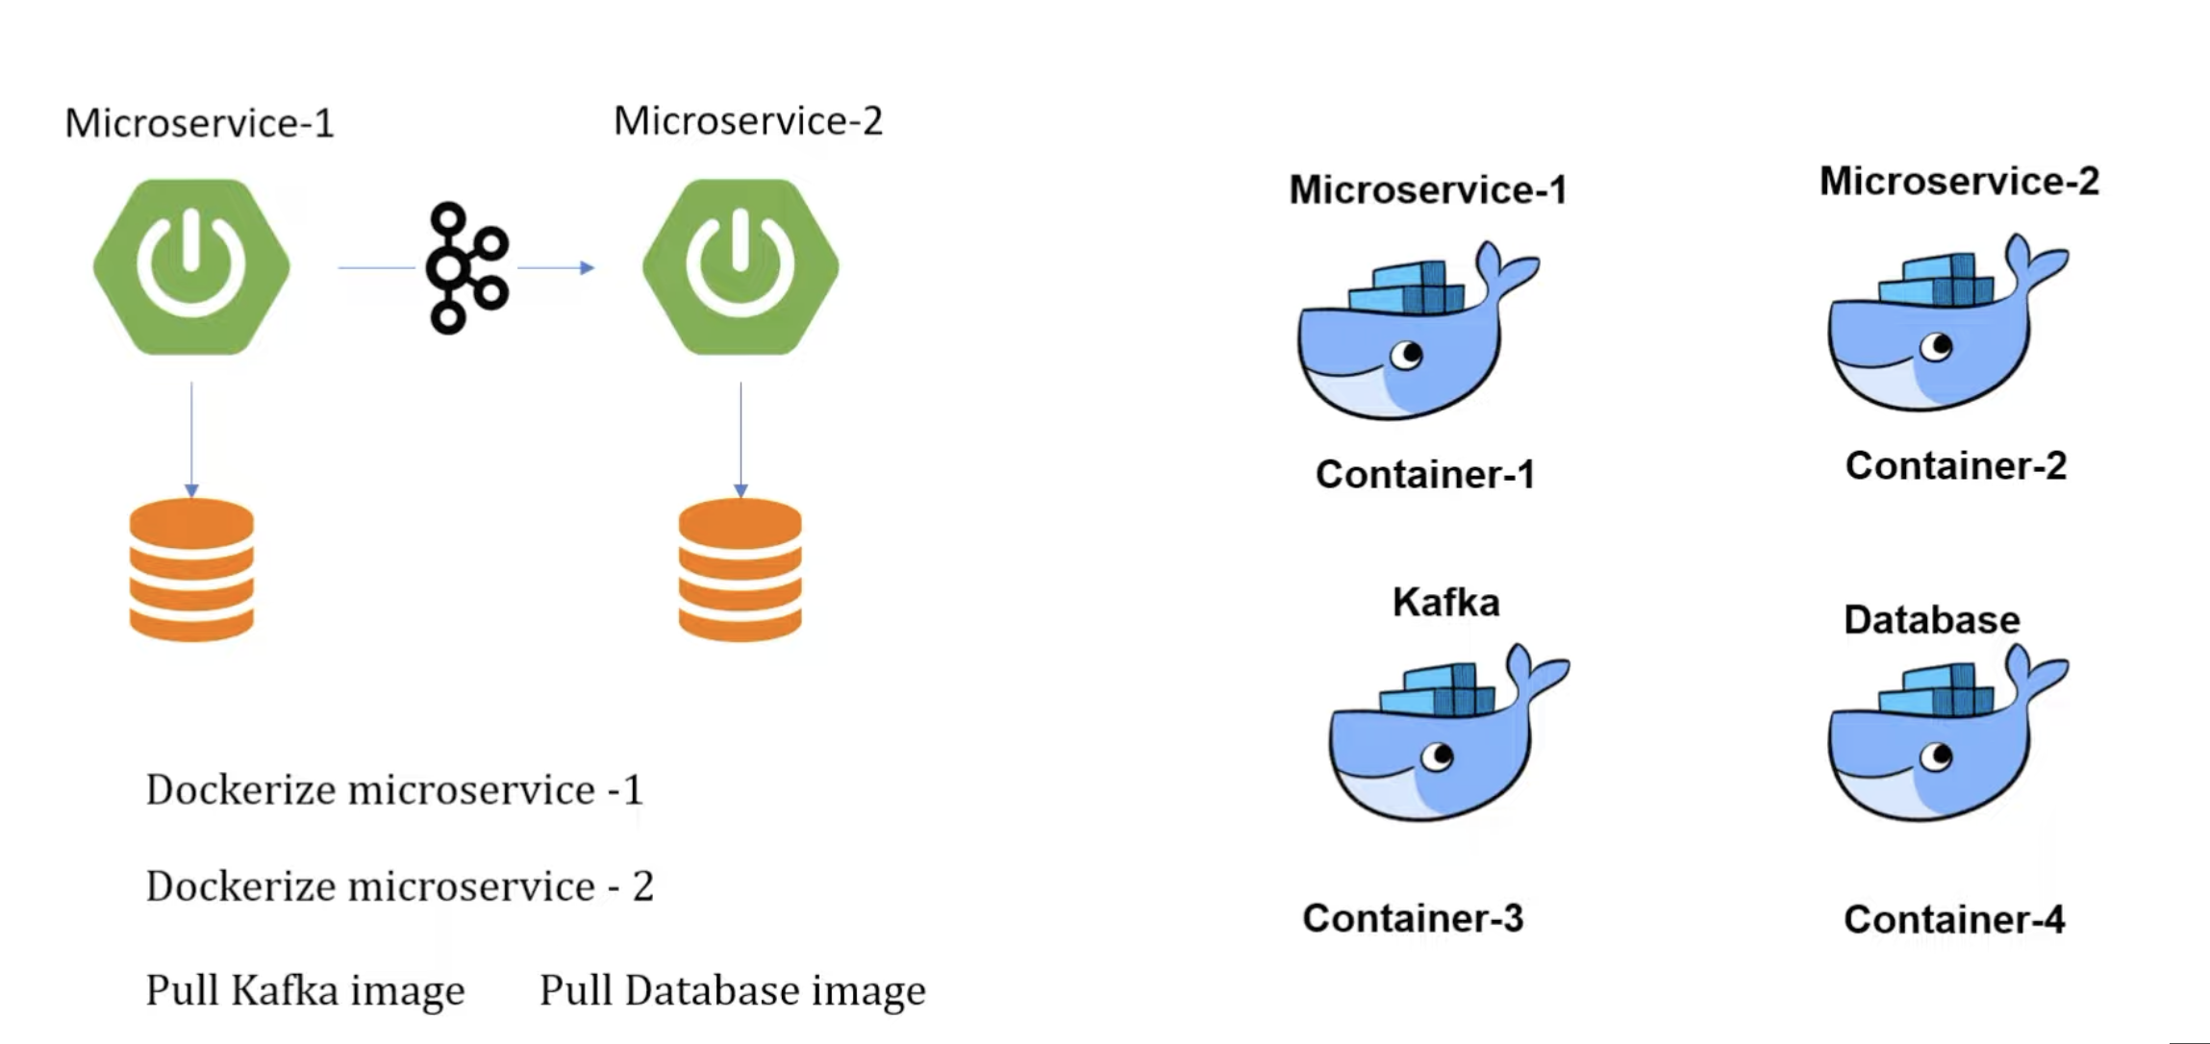

We can create the docker images of these 4 instances and deploy it to the containers. Now, we have only 4 containers so we can manage it but in actual like Walmart, amazon there are multiple containers which are communicating with each other and it’s very difficult to manage. When we are talking about managing the things, we are doing below things:

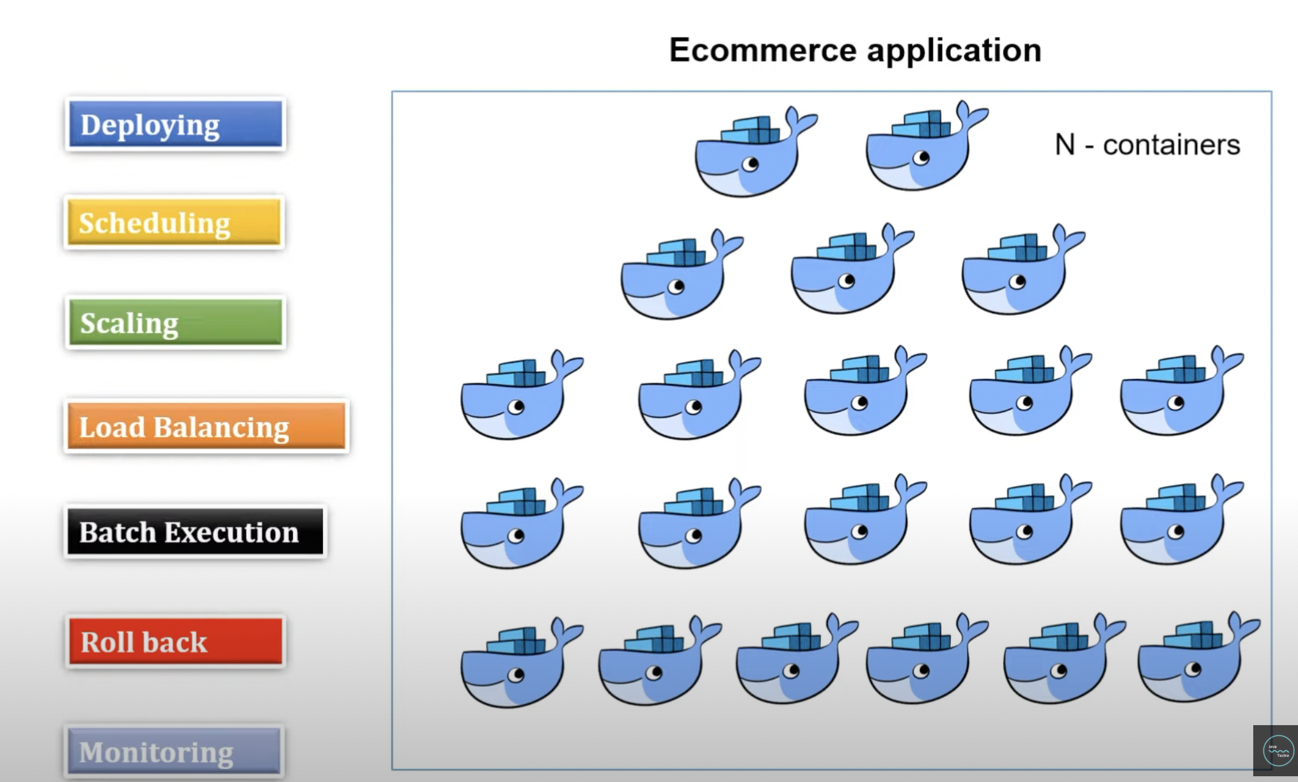

You just need to create the docker image everything else will be manage by Kubernetes itself. There are other tools like docker-compose, marathon is also available in the market but Kubernetes is widely used in the market because it also provides deploying, scheduling, scaling etc. features.

**Components of Kubernetes:**

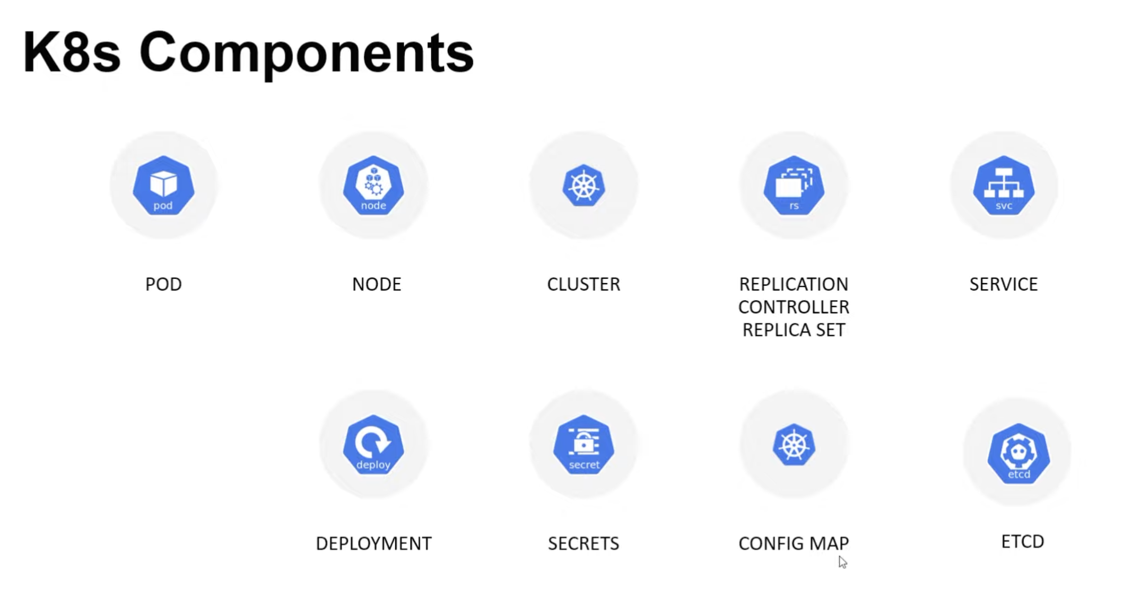

**Let me explain these components:**

1. **Pod**: Kubernetes don’t interact with containers directly. When we are talking about container it means the docker image that we deploy on some container. First, we create the docker image of spring boot application and after that we deploy it on some container. So, these containers are managed by the Kubernetes, but Kubernetes don’t interact with these containers directly. Containers are wrapped into the functional unit that is called pod. Pod can have one or many containers and each pod has IP address on the behalf of this IP address they interact with other pods.

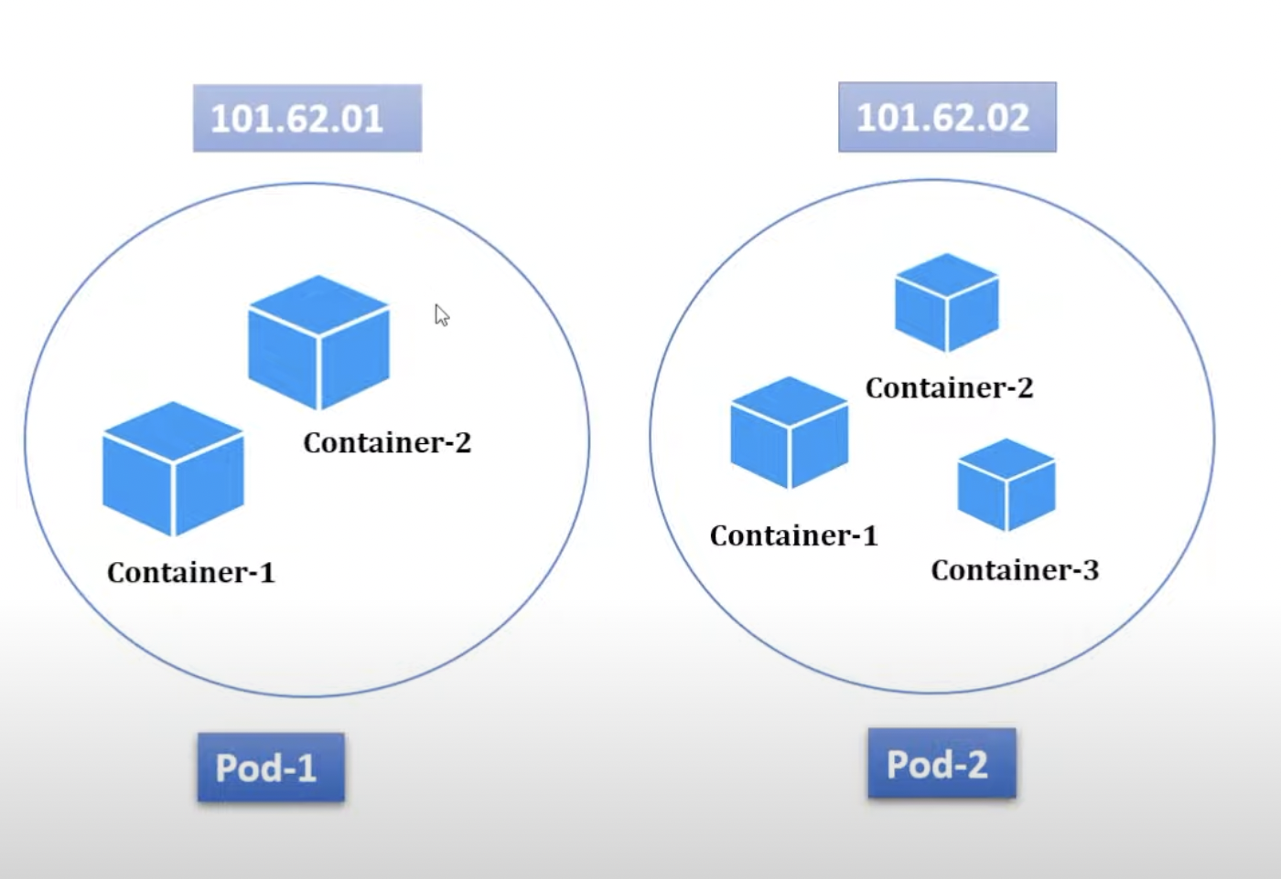

1. **Node:** There is another virtual machine, where all pods are wrapped into single unit that is called node. Node can have single pod or many.

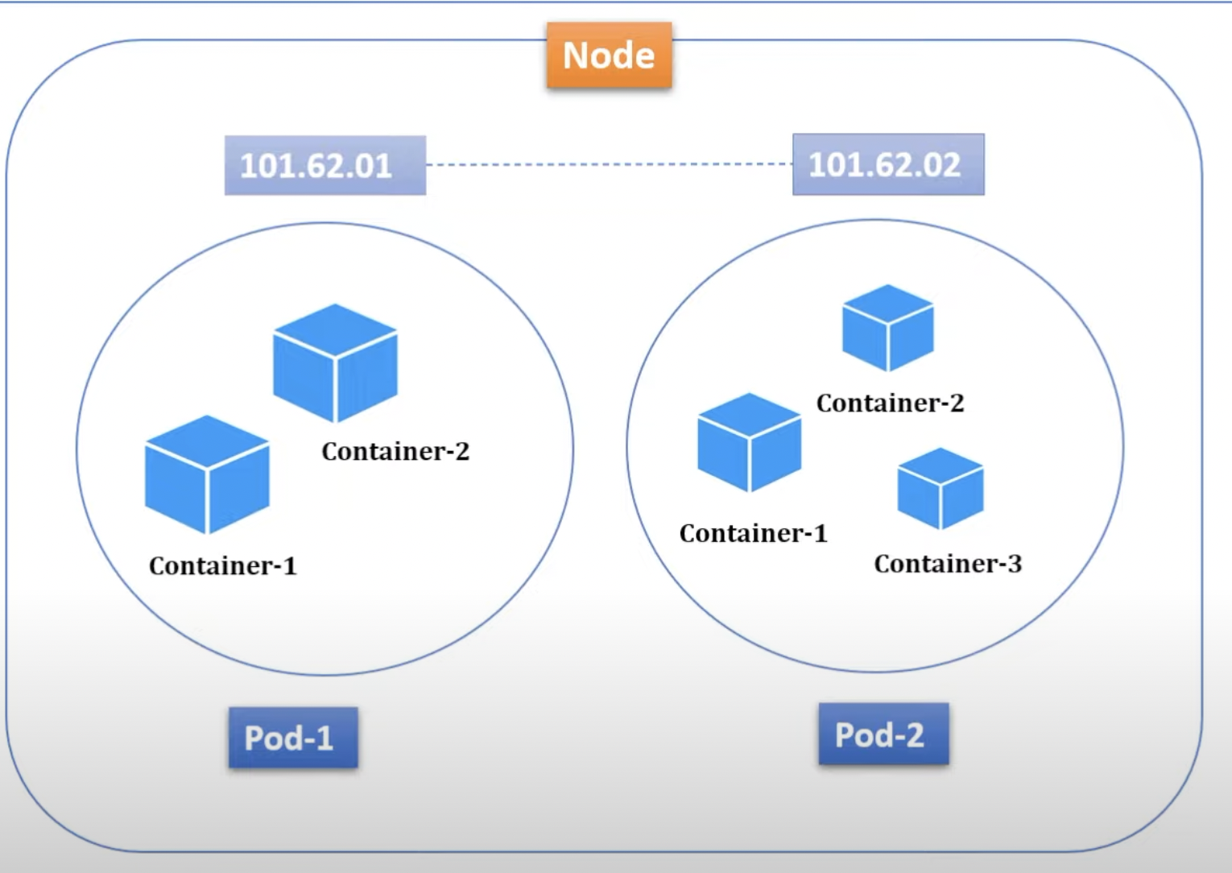

1. **Cluster**: Multiple nodes are wrapped into one unit is called cluster. Cluster can either have single or multiple nodes. Cluster is comprised of one **master node** and multiple **worker nodes**. These nodes either can have physical computers or virtual machines depending on the cluster you have created.
2. **Replication Controller/ Replica sets**: As we discussed pods run under the node and each pod is associated with unique IP address. Suppose I have one Database docker image into one pod. Our spring boot is interacting with this DB pod but to some reason suppose network issue this pod got crashed so how our spring boot app with interact with this pod? So, to avoid this issue there is a concept of replica sets, in which we mention that we need n number of replicas of this pod. In-case, it got crashed at the same time, it creates a new pod and assign IP to it and our spring boot app will interact with that pod. So, this way there is no downtime for spring boot app.

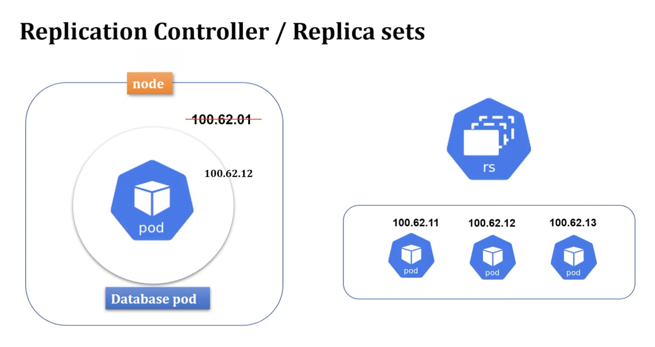

1. **Service**: Suppose we have a node, in which we have 2 pods (frontend, backend). Frontend connects with backend to display the things but due to some reason our backend app goes down. We know, in this case replica set will start the new pod and new IP will assign to it and now fronted will use this pod to connect with to display the things but suppose it goes down continuously so IP address will change suddenly, and, in this way, our frontend will not work. So, to avoid this issue, service comes into the picture. It will provide the DNS name so instead of using IP address we can use the DNS name and it will not change even though our IP address changes continuously.

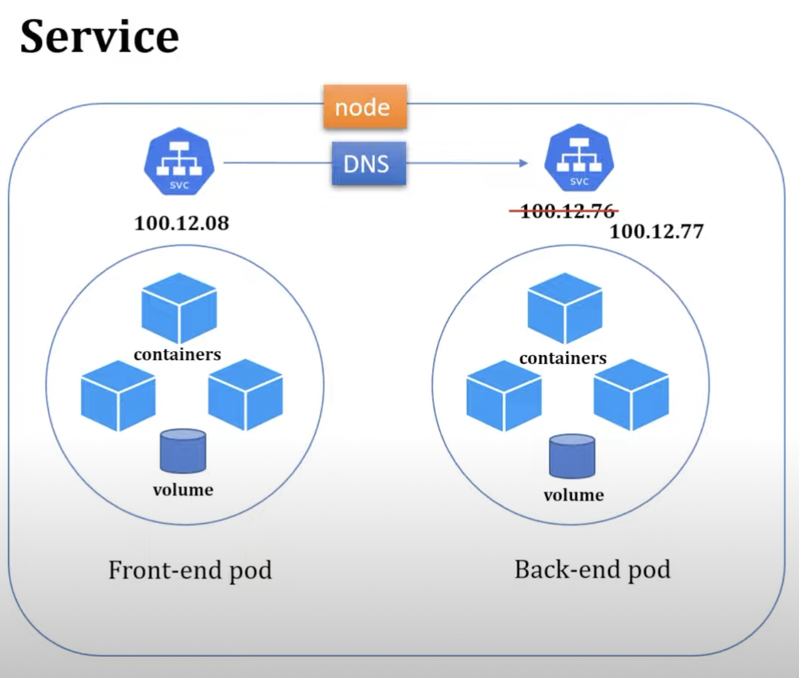

Service also plays the role of load balancer where traffic coming to the service will handle and it redirect to the available pod. There are different types of service available.

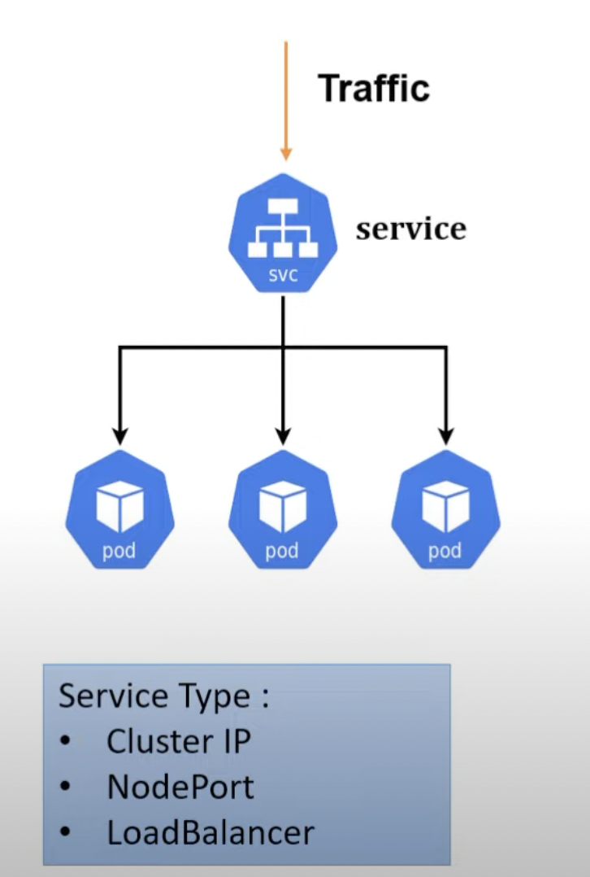

1. **Deployment**: are the Kubernetes object that are used for managing the pods. You can scale your application by increasing the number of running pods or update the running application using deployment object:



1. **Secrets and ConfigMap**: These properties are external from pod. There is a reason behind this. Suppose we want to change the credentials and after changing credentials we need to create the docker image of spring boot and then containerized it and then we will create the pod for it. So, just changing of credentials we are doing everything from scratch so it’s good to put credentials somewhere on different location instead of putting it inside the pod. Moreover, due to security reason, it’s not a right approach to put credentials in the **application. properties** file. Suppose we have MySQL credentials so we will save the username, driver inside the ConfigMap because it is in plain text and password we will save into the secret in encrypted form.
2. **ETCD**: Kubernetes uses etcd as a key value database store. It stores the configuration of the Kubernetes cluster in etcd. It stores all the secret and ConfigMap data inside etcd database. The maximum limit to store secrets is 1MB.

**Master node and worker nodes explanation:**

Let’s take an example of Manager. What are the roles and responsibilities of manager:

1. Manager will monitor all projects are running smoothly or not.
2. Manager will check whether all developers are working or not.
3. If any developer left the project, immediately he will assign a new resource.
4. If any project closed/completed, then immediately he will tag all developers to new project.

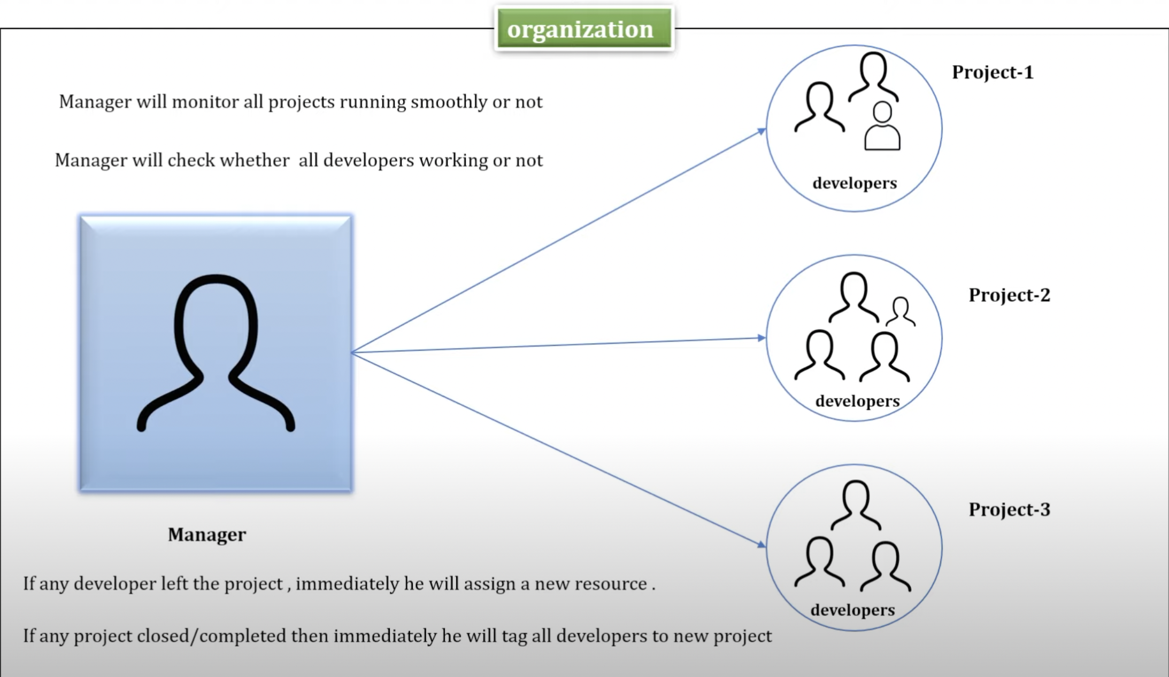

Here are some jobs that is done by master node:

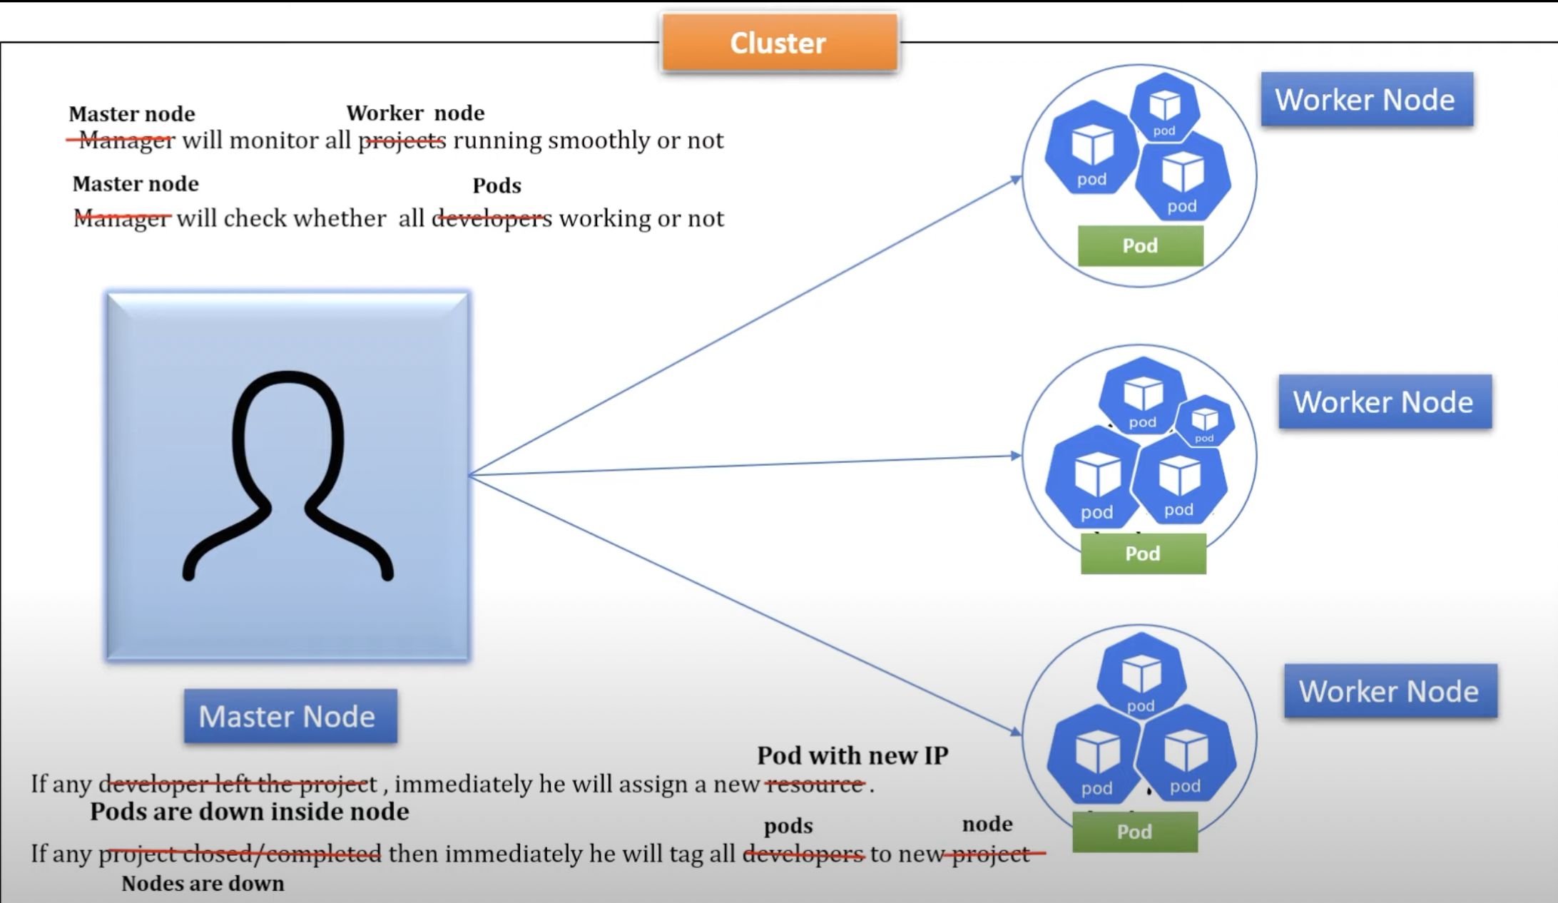

In Kubernetes, there should be at least one cluster, one master node and one worker node. Master node basically manage the cluster and it basically monitor nodes and pods. Master node has 4 components mentioned below:

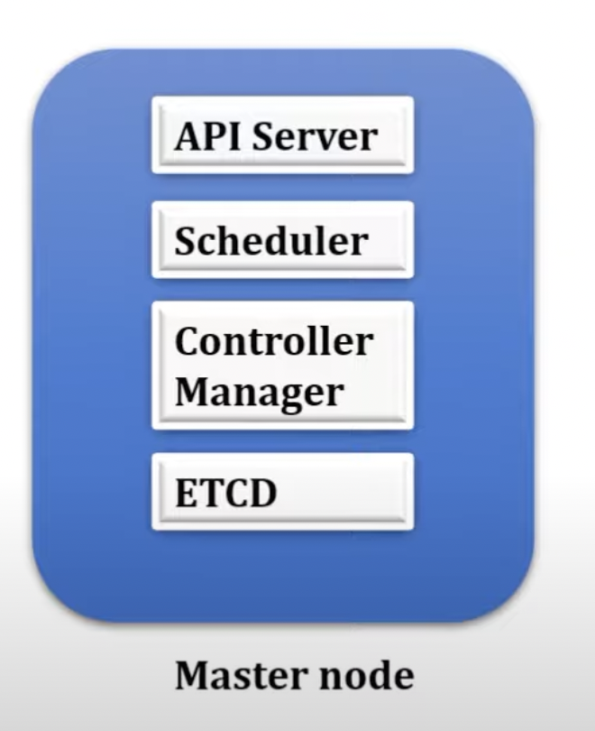

**API server:** It will act as Cluster gateway; the any request comes to the cluster will first come to API server. API servers expose few APIs to access all the operations going under the cluster. You can access API server using command line tool called Kubectl or K8s UI. Suppose, I want to check the status of pods and nodes. We can check it using command:

1. Kubectl get nodes
2. Kubectl get pods

When we hit these commands, it will not go directly to the worker node to check the status of nodes and pods. The API server will check the status of nodes and pods using its endpoints and

It will give you the status of nodes and pods.

For creating the cluster, we will create the shell scripts for it:

**Kind-config.yml:**

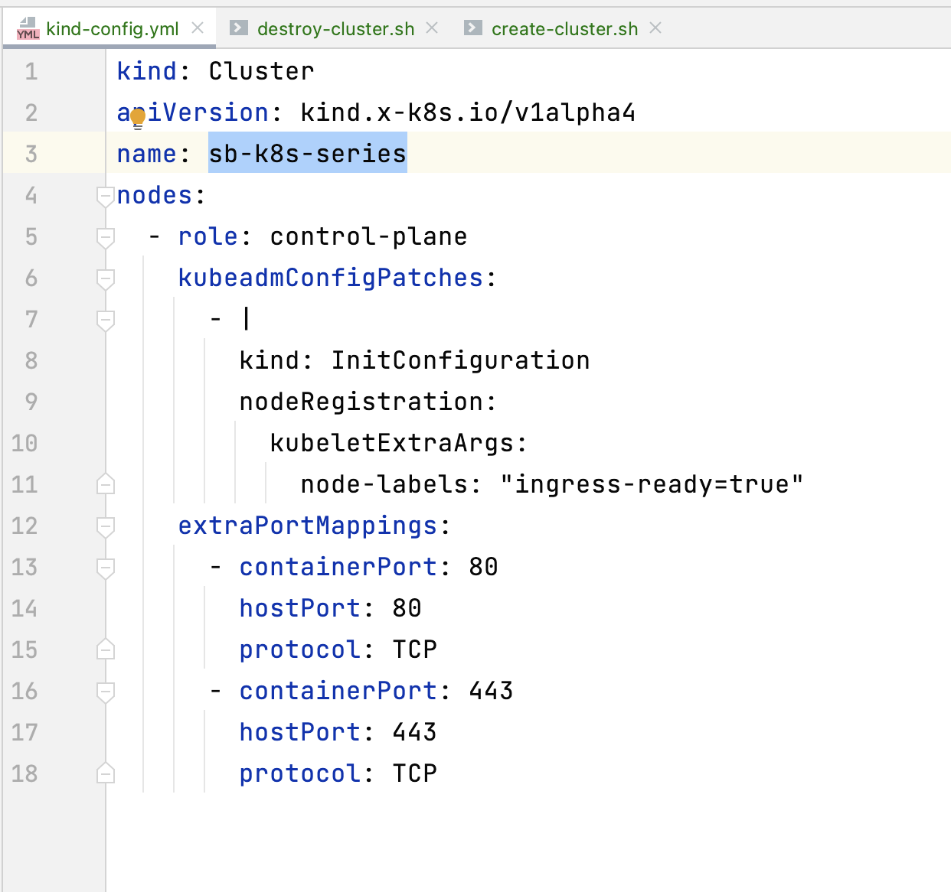

**create-cluster.sh:**

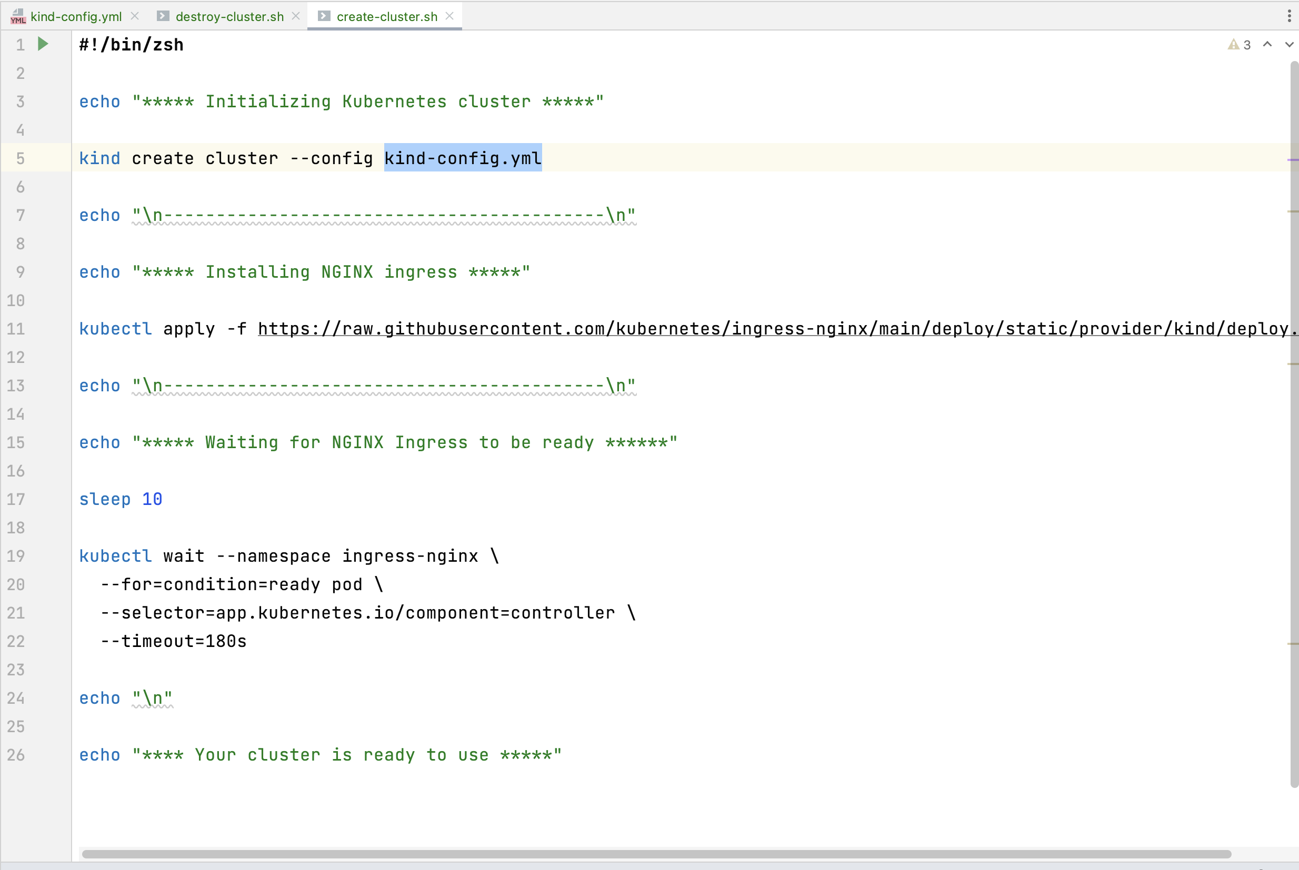

**delete-cluster.sh:**

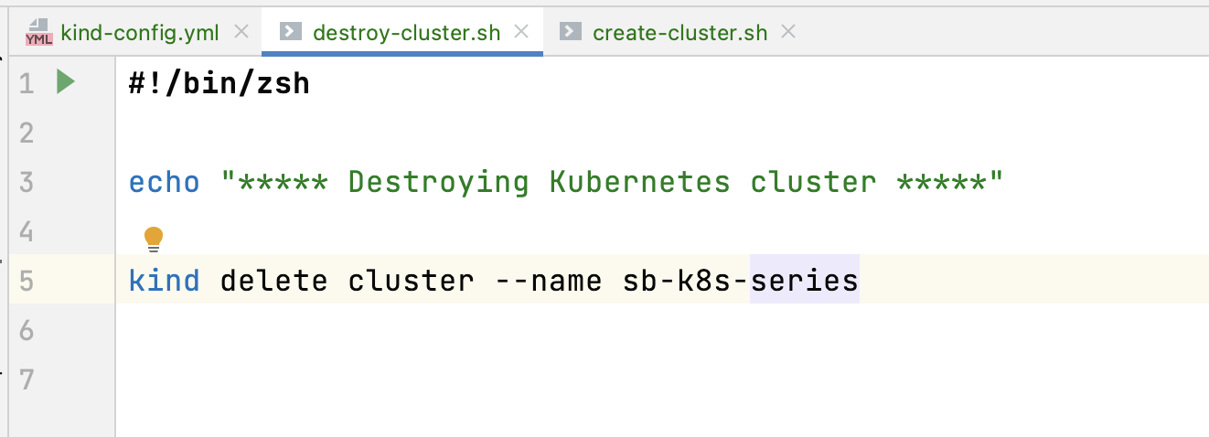

Once you create the cluster, download “lens” software for Kubernetes UI:

Download link: <https://k8slens.dev/>

Credentials:

Email: mani*****

Pass: Si****1

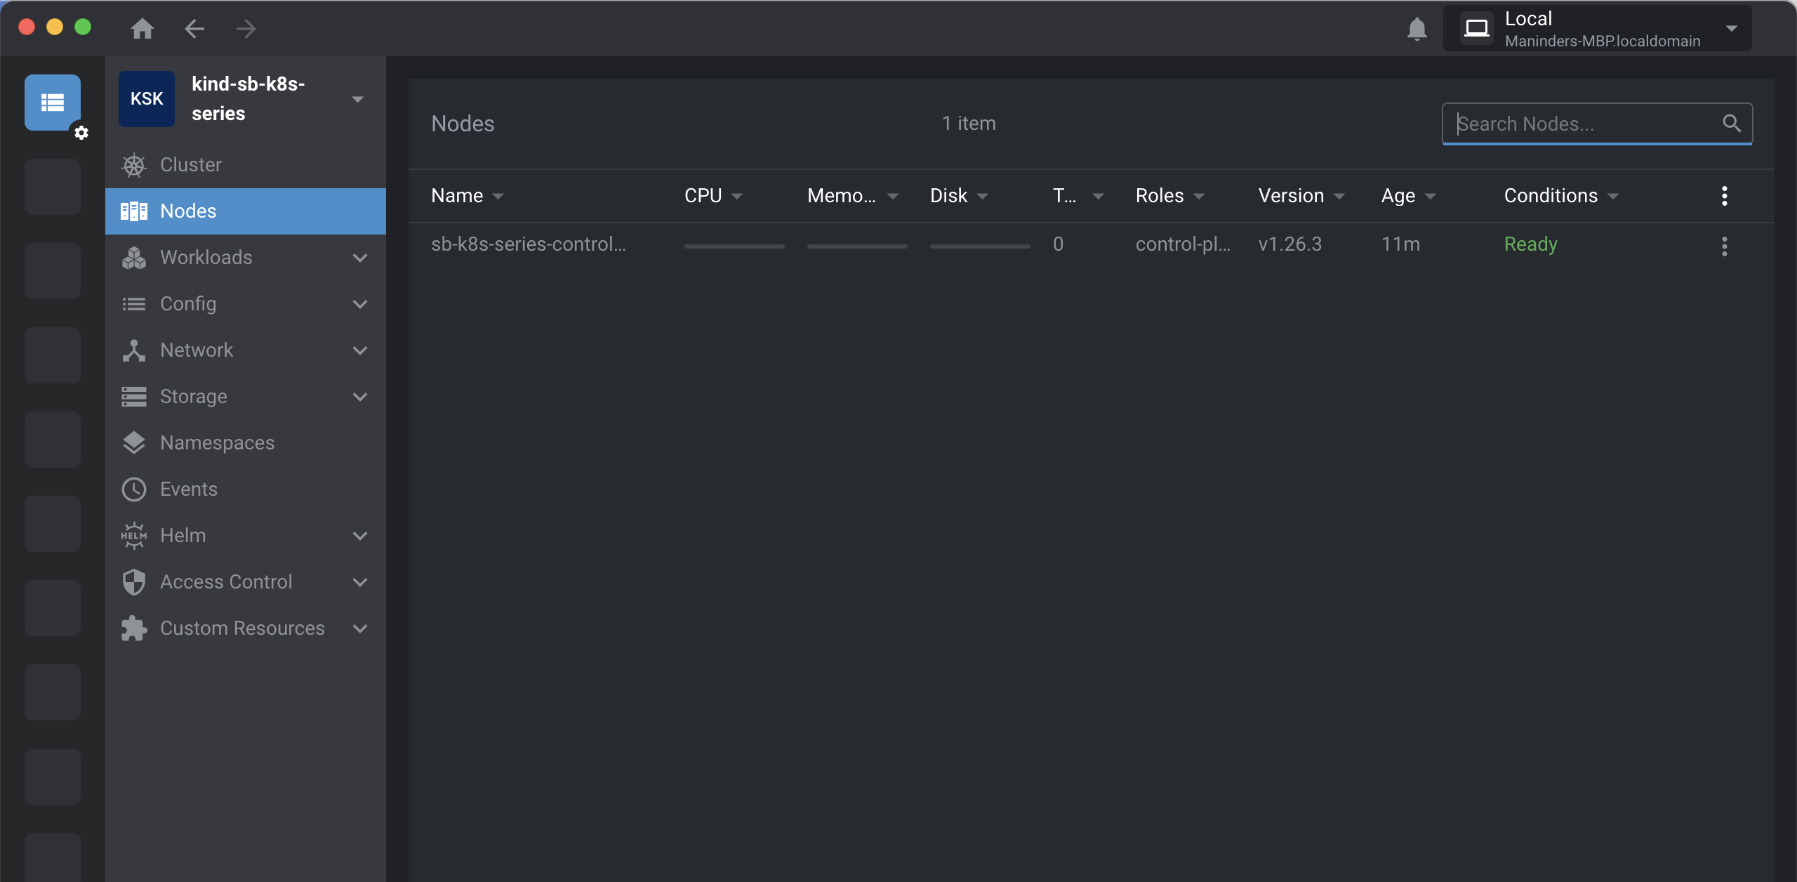

Commands for Kubernetes:

1. To check does pods exist:

**kubectl get pods**

1. To create pods:

This command was not working for me. Means I was able to create the pod but pod was not able to access the docker image:

**kubectl run bookmarker-api --image=maninder40407/bookmarker-api-lib --port=8080**

**bookmarker-api:** pod name

**maninder40407/bookmarker-api-lib:** image name

so, I tried:

created one yml file named as “pod.yml”:

run the command: **kubectl apply -f pod.yml**

pod.yml:

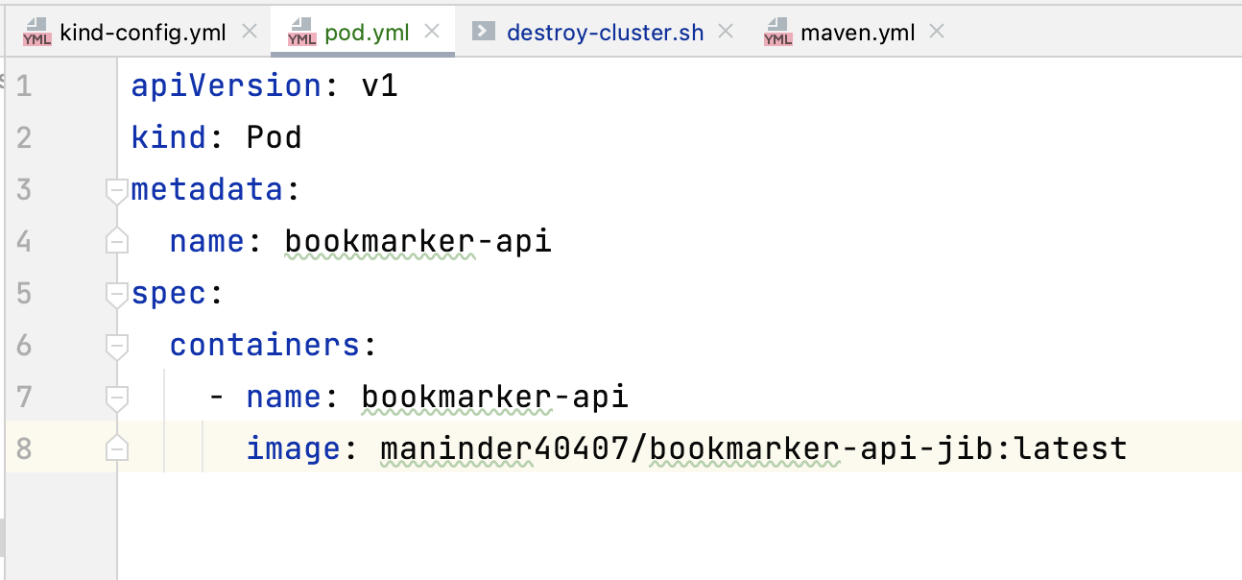

In this, I have mentioned the docker image name and now if I check the status of pod it is working fine:

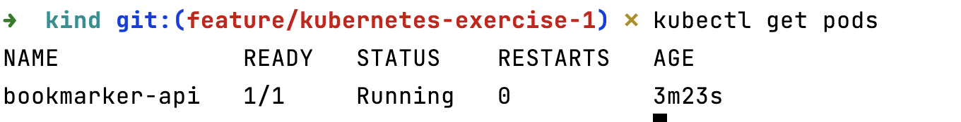

If you want to check the logs of pods you can use command:

“**kubectl logs bookmarker-api**”

“**kubectl logs bookmarker-api -f**”: it will load the logs continuously.

Now, let’s check either the pod is able to access the localhost:

Go inside the pod, using command:

kubectl exec -it bookmarker-api -- /bin/sh

install curl, if not installed:

apk --no-cache add curl

Able to access localhost:

